

Naaya administrator's manual
Naaya toolkit for EnviroWindows
Prepared by
Miruna Bădescu
October 2010
Version 1.3
User guide
Version management
No | Date | Changes | Author
1.0 | 10 Aug 2007 | First version | Miruna Bădescu
1.1 | 15 Oct 2007 | Users and security chapter added | Miruna Badescu
1.2 | 4 Jul 2008 | Added explanations about the new HTML editor, portal map and survey tool | Miruna Badescu
1.3 | 3 Jun 2010 | Updated versions – added updated information on the HTML editor, added portlets chapter, photo gallery chapter, consultation tools chapter, discussion forum chapter, helpdesk agent chapter; updated the survey chapter | Miruna Badescu
1.4 | 13 Oct 2010 | Added paragraphs on portlets and made small grammar improvements | Andreea Teodorescu

Project manager: Paolo Meozzi, EEA
Contents
1. Setting the scene 4
2. Terms, abbreviations and acronyms 4
3. Naaya overview 5
3.1. Extensibility 5
3.2. Modularity 5
3.3. Levels of administration 6
4. Content management 9
4.1. Content types 9
4.2. Publishing workflow 21
4.3. Folder-level 21
4.4. Portal administration 26
5. Translate the website 29
5.1. The language negotiation process 30
5.2. Multilingual content 30
5.3. Multilingual interface 32
5.4. Multilingual searches 34
5.5. Multilingual syndication 34
6. Change the layout 35
6.1. Portlets administration 37
7. Users and security 39
8. Discussion forum 41
9. The survey tool 42
9.2. Taking the survey 47
9.3. Analysing the results 47
10. Consultation tools 48
10.1. Naaya Consultation 49
10.2. Naaya TalkBack Consultation 51
11. Photo gallery 53
12. Helpdesk agent 56
12.1. Administration 56
12.2. Usage 58
13. References 59

Setting the scene
This document describes the content management and maintenance operations that an administrator of a Naaya portal for EnviroWindows can perform.
Currently, all EnviroWindows portals are hosted on the EEA servers at:
- http://root.ew.eea.europa.eu
- http://root-destinet.ew.eea.europa.eu/
- http://root-smap.ew.eea.europa.eu/
- http://root-devel.ew.eea.europa.eu/
An application for creating a new portal on this same server can be made from the EnviroWindows website (http://www.ew.eea.europa.eu/applicants).
Alternatively, separate installations of the software can be done on different locations since Zope (released under the Zope Public License http://www.zope.org/Resources/License), Naaya and its extension for EnviroWindows (released under the Mozilla Public License http://www.mozilla.org/MPL/) are all open source applications.
All Naaya source code can be found on the EEA source repository https://svn.eionet.europa.eu/repositories/Naaya/
Further details on Naaya installation issues do not fall into the subject of this guide, they are included in the Naaya installation instructions.
In the following, the assumption is that an EnviroWindows portal has been created and you administrative rights on it.

Terms, abbreviations and acronyms

Term | Definition
XML | eXtensible Markup Language
CMS | Content Management System
Zope | An open source application server for building content management systems, intranets, portals, and custom applications
ZMI | Zope Management Interface
PTK | Portal ToolKit
Naaya | A Python-based content management system that works under Zope
EnviroWindows | EEA platform for knowledge sharing and development
EW | EnviroWindows
TAL | Template Active Language, a scripting language for Zope
Remote channel | A summary of content published on the Web in XML format and updated on regular basis. Often referred to as “feed”. Content available in this format is parsed by websites, browsers and desktop applications and presented to visitors as listing of contained items (e.g. latest news from related site). Usually, the presence of RSS/RDF/ATOM feeds is signalled on websites using icons such as or .
Portlet | User interface components that are managed and displayed in a web portal. They produce fragments of markup code that are aggregated into a portal page, typically on the left or right sides of the page.
LDAP | Lightweight Directory Access Protocol is an Internet protocol that email and other programs use to look up information from a server. Simplified, it can be compared with an address book.

Naaya overview
Naaya (http://naaya.eaudeweb.ro) is an open source portal toolkit with support for content management, multilinguality, syndication and friendly through-the-web site administration for webmasters with all kinds of technical backgrounds.
Naaya portals target users are people that want to quickly start a website and reduce to a minimum the need to refer to technical system administrators for its update and maintenance. They can delegate authority for content management and local administration to a team of non-technical contributors.
Things like access statistics, mapping domain names to the portal, running jobs at regular intervals, updating the software on the file system or installing new modules still require technical intervention, but these are not daily tasks and are usually taken care of by the network administrators.

Extensibility
This platform has been built in a flexible way, which allows:
- adding other components from the Zope open source community,
- replacing various modules to fit custom needs or
- enhancing existing components to comply with emerging Web standards or respond end user demands.
So, if you are working on a Naaya portal and need a functionality which is not included in the standard package, it is very likely that somebody has already written an open source component for it (e.g. a blog product, integration with external databases); if this is not the case, an additional component can be developed and added to Naaya.
In comparison with other similar systems such as Plone, plugging generic components or integrating existing ones is quite straight forward and does not require extensive knowledge of the Naaya design and architecture.
Components such as the Yahoo-based maps were re-used in the EEA's website (which is built in Plone) after their initial implementation in Naaya. Reusing open source components from one system to another leads to low development costs when it comes to new functionality and allows the portals who use them to stay updated with modern technology and standards.

Modularity
Naaya has been built over the years, following the user requirements gathered from several communities, but its features prove to be quite typical for most modern portals. Since various networks of portals as well as stand-alone applications are powered by Naaya, it is bound to contain very specific functionalities at some point.
That is why Naaya portals are based on a core set of generic modules to which a custom component can be added, in order to overwrite some functionality or add features only required in that context. EnviroWindows is one of this cases.
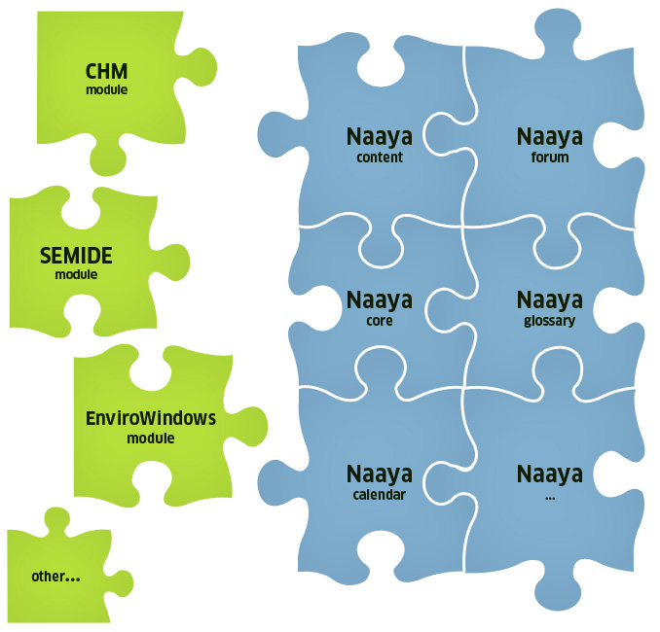Figure 1: Naaya - plug and play components
A special advantage is that, after creating multiple portals on the same Zope server, one can individually customise each portal. Among others the layout, the wording on the forms, the portlets, etc. can differ. New functions can also be written for each portal.

Levels of administration
The administration and maintenance of Naaya websites can be done from the ZMI (Zope Management Interface) by users having the Manager role in the portal. However, this management console is meant to be used by people with technical backgrounds and with a certain level of Zope knowledge.
Therefore, an Administration area is provided to facilitate users with the role of Administrator to make basic maintenance operations and customisations of their portal. Administrators are intended to be users with full decisional rights over the content and presentation of the portal, but not necessarily technical people.
The rights granted to an Administrator are included in the ones granted to a Manager so, when a person has the Manager role, there is no need for him or her to also have an Administrators role.
You can reach the Administration area by selecting the Admin option from the top services links list after logging in with the proper rights. In here, all functionalities are listed in the right-side Administration portlet.
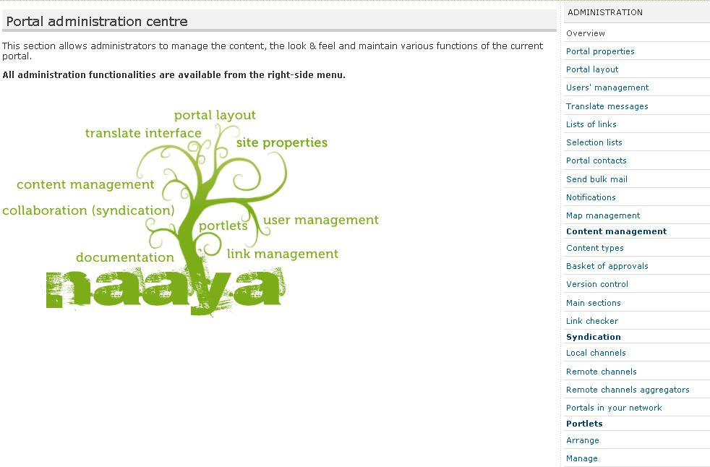Figure 2: Portal administration centre
Basically, all operations available from this administration centre are presented inside portal pages and therefore are easier to use because the sense of navigation in the website is maintained. Moreover, each page contains explanatory texts to guide users in executing the operations and help them understand the impact each operation will have to the portal.
On the other hand, the ZMI offers a much wider range of functions, such as undo operations, database (ZODB) management, refined modifications to each Zope object, language management, administration of glossaries and thesauri, etc. For a basic understanding of Zope’s mechanisms and of the ZMI operations, read the online documentation at http://www.zope.org/Documentation/. The Naaya-related objects and operations that can be performed from the ZMI will be partially explained in this guide.
If you are logged into the system as a portal manager, you can reach the ZMI by typing the site URL followed by “/manage” in a browser:

http://<portal_url>/manage

Figure 3: Zope Management Interface
Aside from the portal-level administration, a folder-level one is available for local Administrators, in order to be able to;
- manage content in that folder and below in the hierarchy (sub-folders)
- manage the right-side portlets displayed here
- manage users
- potentially add a custom logo to be displayed in the right side of this folder and it’s sub-folders
- customize the site’s feedback form
Since the policy is for the portal administrator to fully delegate authority to local administrators, it is possible to allow visitors that navigate in these folders to send a feedback through the site’s feedback form either to the site administrator’s or to the local administrator.
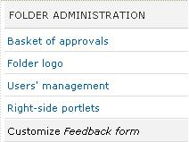Figure 4: Folder admin
Whenever a local administrator will log in and navigate to the folder he is granted this privilege for, he will see the right-side portlet called “Folder administration” that contains links to the functionalities described above.
Further in this document, all sections that are addressed to the Managers will be marked with the following formatting:
Example text for the Managers

Content management
Before explaining the operations that can be done upon the content, let's take a look at the content types available by default in EnviroWindows portals. As explained before, new types can be created and added as needed.

Content types
When you have a piece of information that you want to see published in the portal, the first step is to decide what type of content would better accommodate it. It is important to put the data in the right format because each type has a different set of attributes which can later be used to correctly index and categorise it.
All types have a common set of attributes that generically describe resources. They are called metadata. Since fully defining a resource implies generically describing it and also describing its custom characteristics, all Naaya content types have:
- a common set of properties (e.g. title, description, release date, contributor);
- a custom set of properties (e.g. location for events, expiration date for news);
- a dynamic set of properties, which are are only relevant for one website and are defined by Managers for each portal, individually (e,g, CV for experts).
Since multiple Naaya portals can reside together on the same Zope server, dynamic properties of objects allow fulfilling the needs of each portal without impacting on the genericness of the software product.
Managers need to enter the ZMI -> portal_dynamicproperties -> add “Naaya Dynamic properties item” for the content type they want to add properties to -> and define each additional property here.
Upon adding a dynamic property to a type of objects, it is immediately added to all existing objects with the predefined value you specify. New objects added from that point on will also have that property. Moreover, the submission and editing forms for those objects will automatically contain that field.
As you can see in the screen shot below, it is possible to choose the type, a predefined value, predefined list of choices, etc.
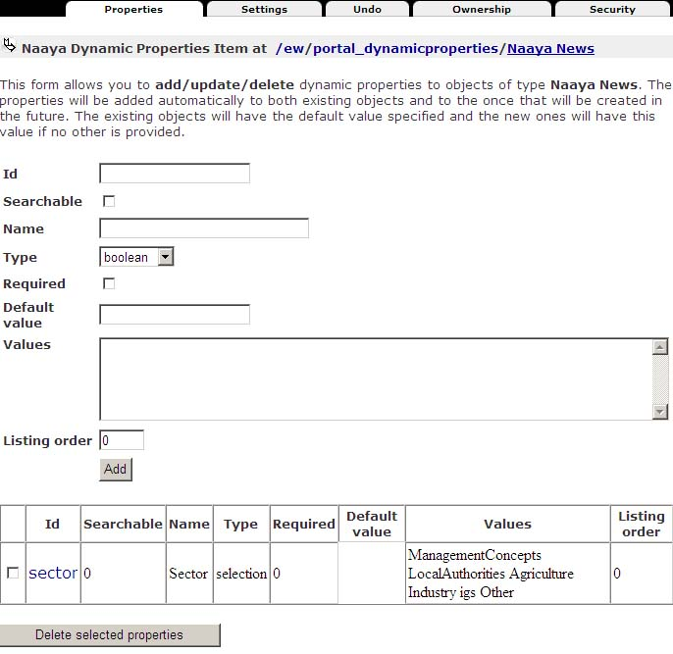Figure 5: Define dynamic properties for objects

Folder
Folders are containers of information, similar to the ones from the operating systems. They also have metadata attached, in order to help describe and the index the data inside them.
Throughout this user guide, folders will be also referred to as sections.

HTML document
Use this type to build a generic Web page. A friendly editor will help compose the pages, without you having to actually write HTML code.

The HTML editor
Here's a list of operations that can be performed using this interface:

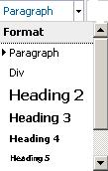 | choose the formatting of the selected text using the existing, predefined tags:  - paragraphs (usually contains an idea, separated visually by a space before and after it)  - div (rectangular box containing text and images)  - headings (each page must contain one and only one heading 1, which is the title of the page, put automatically by the application. Therefore, you can choose between headings 2 to 6.  - blockquote (a block of text containing a quotation of somebody's words)
- choose the text appearance and size from the given lists.
Note: by default, the appearance and size of the fonts are the ones defined in the portal layout and are the same throughout the entire portal for each element. This gives portal visitors a sense of consistency. Changing these attributes of the text should be done rarely and for good reason. Remember that writing for the Web is not the same as writing for print and that different users have different means to see the web page (different screen resolutions, mobile phones, smaller monitors, speech interpreters, etc.), so the pages must scale nicely and be accessible to everybody.
- select the text and make it bold, italic, underlined or strike through
- align the text to the left, middle or right sides of the page
- make ordered and unordered lists
- align text more to the left, middle or right sides of the page; the last option allows you to justify the text, meaning stretch it until the end of the available area
- insert/edit anchor, insert/edit link and remove link buttons.
Anchors are points in that same page (usually sub-headings) to which visitors can jump for easy navigation (e.g. “Top of the page” or “Next chapter”). They are used in long pages, to avoid the need to scroll. The insert/edit anchor window allows you to enter the name of the anchor. Remember the anchor name needs to be unique inside a page.
For the links insertion or editing you must first select the text you want to appear in the link or that you want to unlink. The link button opens a window that allows inserting the desired URL and a title for it, but also select an internal link from the sitemap:
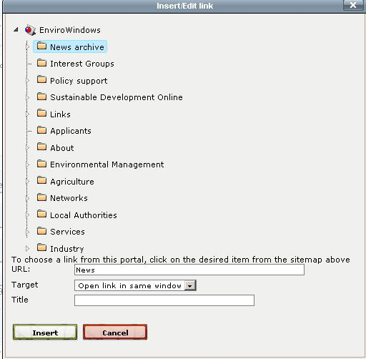

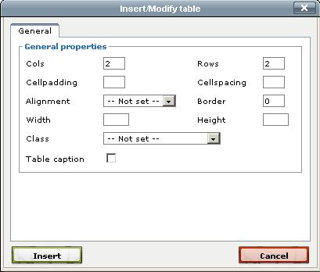
- insert tables and customise their appearance. First click the “Insert a new table” button (first in the list) and choose its various generic settings:

After the table appears in the area you are editing, the rest of the table-related buttons will be enabled. When you move away from the table, those buttons will be disabled again. Clicking inside an existing table will re-enable these buttons.
You can:
  - set the table row and cell properties
  - insert a row before or after another
  - delete a row
  - insert a column before and after another
  - delete a column
  - split columns
  - merge columns
- insert horizontal rule in the current location
- removes formatting from the selection; especially useful when pasting text from another source, such as MS Word or another Web page, and you want to remove the different styles copied from the other application. However, this button is not able to remove all formatting, especially not from the Microsoft applications which have their own embedded styles. For a complete removal, use the “Paste as Plain Text” button (see below).
- makes the selection to be subscript or superscript
- the “Paste as Plain Text” and “Paste from Word” buttons are meant to remove the “bad” code copied along with the text. Pasting text copied from other applications without removing the initial formatting has the following downsizes:
  - the text might not maintain the level of accessibility provided by Naaya applications. By accessibility it is understood the possibility for users with different browsers, types of devices, operating systems, different internet connections and so on.
  - the pasted styles might not match the ones used in the current site
  - the result of mixing the original styles with the local ones can create unexpected results
Both these options open a small pop-up window that allow you to paste the text and click “Insert”. The system will then do the necessary cleaning of the code. The first one is the safest as it removes ALL styles and formatting, while the latter only removes a part of them and preserves things like alignments, paragraphs and colours.
- change the font colour for the current selection
- change the background colour of the current selection
- inserts or displays an image. For a new image, just click on this button from after you ave positioned yourself in the desired position in the text. In order to change the settings of existing images, first click on the image to select it and then click on this button.
This button opens a pop-up window that allows you to specify the URL of an image. If the image is located outside your website, just put the external URL. If the image needs to be uploaded from the local computer, use the Computer tab to upload it and then click on it from the list below. If the image is or should be local, then you can push the little button next to the “Image URL” field, Browse:
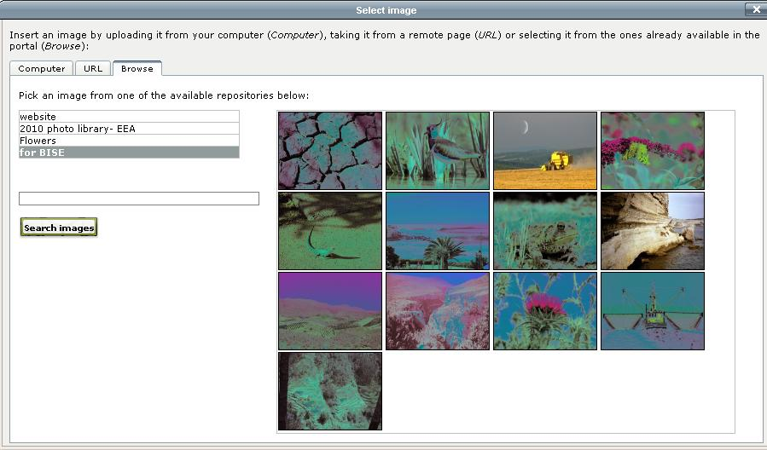
When you select the Browse tab, a list with all available picture albums will be displayed. You can select an album, and you will be shown all the pictures inside that album. Select a picture, click on it and you will have it available in all sizes. You will then select the required picture size, by clicking on the “Save size” button.
Once you've made your image and image size selection, you can proceed to the following step, which is defining the customize attributes, and fitting the image in the text.
You need to provide an alternative description of that image in order to make its content accessible to people with disabilities. The image description is also for the better indexing of your portal pages. It results in better searches when using the internal search mechanism or in external engines such as Google.
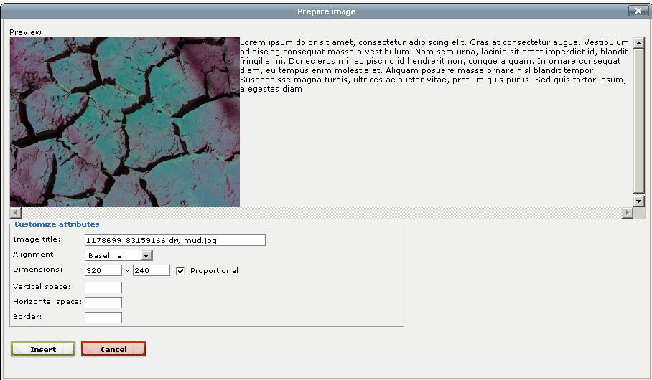
The final step is to prepare the image, by setting its title, alignment (left, right, baseline,bottom, middle, etc.), dimensions, vertical and horizontal space, borders, and insert it, as in the figure below:

- the preview button lets you know how your text is going to look like
- the “Clean up messy code” removes unwanted formatting
- the HTML button displays the HTML code and lets users with technical background write more complex code.
Please note that the editor removes potentially unsafe code so, if you know what you are doing and want to write some code which is not allowed by the editor for some reason, just disable the Javascript in your browser for a while. Follow these steps to do so for IE:
  - Tools > Internet Options > Security > Custom Level
  - Scroll down to Scripting and disable Active Scripting
  - Click on the OK button
  - Answer "yes" to: "Are you sure you want to change the setting for this zone?"
  - After this refresh the portal properties page
  - The editor icons will no longer be visible.
  - You can then paste your HTML code in the corresponding field (e.g. Description), which is now a simple text area without the editor
To use the Naaya editor again, re-enable Active Scripting.
- the Help button displays online instructions and good practices on using this editor
- the full screen button which allows expanding the editing area on the entire screen. The same button will be than available to shrink back the writing area to the original size. The editor text area is however expandable by dragging the lower right corner until the text area reached the desired dimensions.
You'll notice the description fields of all objects also allow inputting HTML content. Whenever an object is viewed by portal visitors, the description is shown right after the title, so people tend to use a lot of formatting to emphasis certain ideas and to make the paragraphs look nicely in the browser page.

File
A standard file, briefly described by its metadata. Visitors can download it on their computers or view it inside the browser - proving the right plug-in is installed. The file types are automatically recognised by the system in most cases and the corresponding icon appears next to them.
It is possible to keep old versions of Naaya files for user consultation by selecting the corresponding check-box in the file edit form, as shown in the figure below:
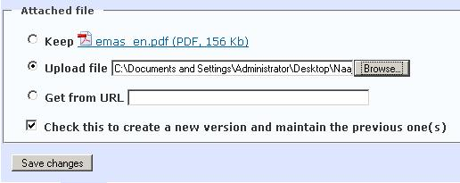Figure 6: File edit form - upload file part
If the file already exists somewhere on the web, you don't have to first download it on your machine and then upload it on the EnviroWindows portal, but just use the URL option from the file upload part of the add or edit form.

Extended file (multilingual)
The difference from the usual Naaya file is that different files can be stored for different languages. For instance, say you want to offer a PDF file for download in all portal languages. You will then use the Naaya Extended File and when translating the metadata (title, description, etc.) in the available languages, you need to also upload a different PDF file for each language.
This way, users will be able to read the entire document in the language of their navigation, not just its metadata.

Media file
When the need to display films, presentations, audio tracks or other multimedia materials inside the portal pages presents itself, you can use this content type to upload the film file in any format.
The film will be converted by the system in Flash format (.flv) at upload time and displayed to visitors in an embedded Flash player. The significant advantage of using Flash against other browser plug-ins (e.g. Windows Media Player, QuickTime Player, etc.) is platform independence, along with removing the need for user to download the file on their computer prior to viewing it.
See a live demonstration of the Naaya Media File at http://test-chm.eea.europa.eu/naaya-objects-demonstration/film-published-eea-site-introduction-film-our
The Naaya Media File also allows inserting subtitles in .srt for each portal language by editing the item and uploading the .srt file or pasting its text inside the corresponding text area.
The Naaya Media File displays the HTML code to use in a different page in order to have the Flash film played on that site. Using this code, you can publish several Naaya Media Files in your site and then gather the code from each for creating portlets, composing on-line presentations or tutorials, present the speakers in a conference, etc.
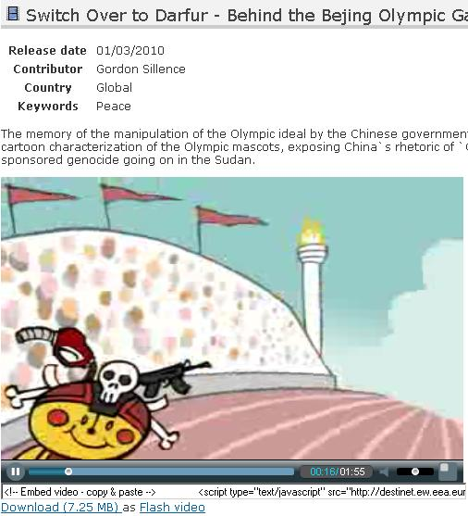Figure 7: Media file on DestiNet
A good practice for the usage of online videos was done by the Integrated Assessment website, with a series of presentations that constitute a frequently asked questions system: http://ia.ew.eea.europa.eu/QAvideos
The Flash film of a Naaya Media File can also be downloaded on the local computer by clicking on the “Download” link under the film.
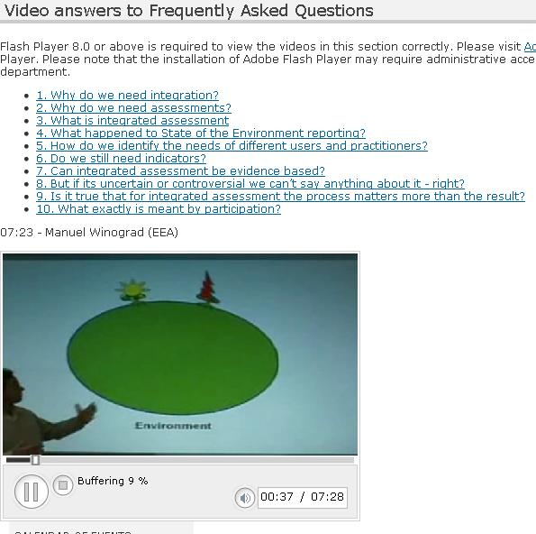Figure 8: Question and Answers videos on the IA portal

News
The news item is a short piece of information with a limited duration of life. Traditionally, news have an expiration date which allows the latest ones to be displayed automatically on the front page and still not have outdated content there.
It is very simple to display news from remote sources of information in the portal pages and also to allow other websites to pick up the latest news from Naaya portals.
The news, events and stories submission is usually left opened to the public or at least for the users with no roles in the portal. This is useful when the community of contributors of your site is small and public contributions comes handy to keep the site live. Therefore, the submission forms for these content types contain a word verification field, which ensures the system that the submitter is a person and not a malicious script:
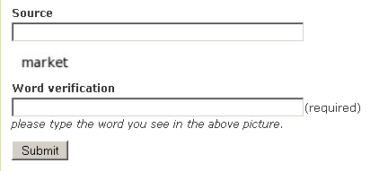Figure 9: Word verification mechanism in the news submission
You can add a small picture and a big picture in a news item. The small picture appears right after the title, when the news is displayed. A bigger picture can be only added when editing the news, in which case the small picture links to the big picture. This is useful in case you want to offer your visitors a high resolution version of an image, but that is too big to publish directly on the news page.

Event
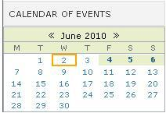Figure 10: RDF calendar
Stores information about an event, a meeting, a conference, etc.
The types of events available are configurable by Administrators
at portal level from the administration area -> “Selection lists” page -> “Event types” list.
Like the news, the events are also syndicated by default and they can be shown under the form of an events calendar. The RDF calendar is able to display events from various sources of information, including the local portal.
A Naaya calendar is also available in the portal. The main difference from the RDF calendar is that this one only exposes the events published in the local website, and that it shows all events, even the ones that took place a long time ago. Usually website administrators decide to only provide upcoming events in their events channel so the RDF calendar might only show future events.

Story
The story is somewhat similar to the news, but with an unlimited duration of relevancy. Stories can contain a longer body, have pictures inserted in it and a small image to be displayed on the front page if necessary.

URL
URL objects contain links to remote pages. They are easy to check at regular intervals using an automatic link checkers and can be described by the metadata.
A special importance is placed on the links management, since they are frequent content types. Therefore, in the administrative area it is available the Link checker, which presents the log of the last run of the automatic link checker and allows you to manually run the check and display results in that very moment. To be noted that the automatic link checker does not only look for broken links found on URL objects, but it is configured to also look for them in the events, news and stories. Managers can further configure it to check any other content types: folders, HTML documents, etc. The links verified are both internal and remote.

Pointer
Pointers are links to internal portal pages. When adding a pointer, a sitemap is displayed to pick from.
Since content can be moved, renamed or simply deleted, internal links may become broken in time. Broken pointers can be easily spotted by Administrators using the link checker.

Expert
Data about a person that has expertise in the area of activity of the portal. The person's domain of expertise is added from a list configured at portal level.

Project
Data about a project that covers the area of interest of the portal. The focuses of the project come from a list defined at portal level.

Contact
Holds data about a person's credentials and contact details.

Geo Point
This content type stores data about certain locations, which are then shown on an interactive map. Based on the address, the system is sometimes able to retrieve the geographical coordinates of that location. All Geo Points published in the portal will be displayed on the map according to their type. The possible operations on the map are: zoom, pan, change backgrounds, identify points.
The types of location are defined in the administration area for each portal. It is possible to filter the points shown on the map from the right-side “Filter locations” box.
Each location type has an image associated with it, usually a pin that will allow you to identify the point on the map. When clicking on a pin, a small window appears, containing the title of the Geo Point and the “see more” link, that leads to the Geo Point index.
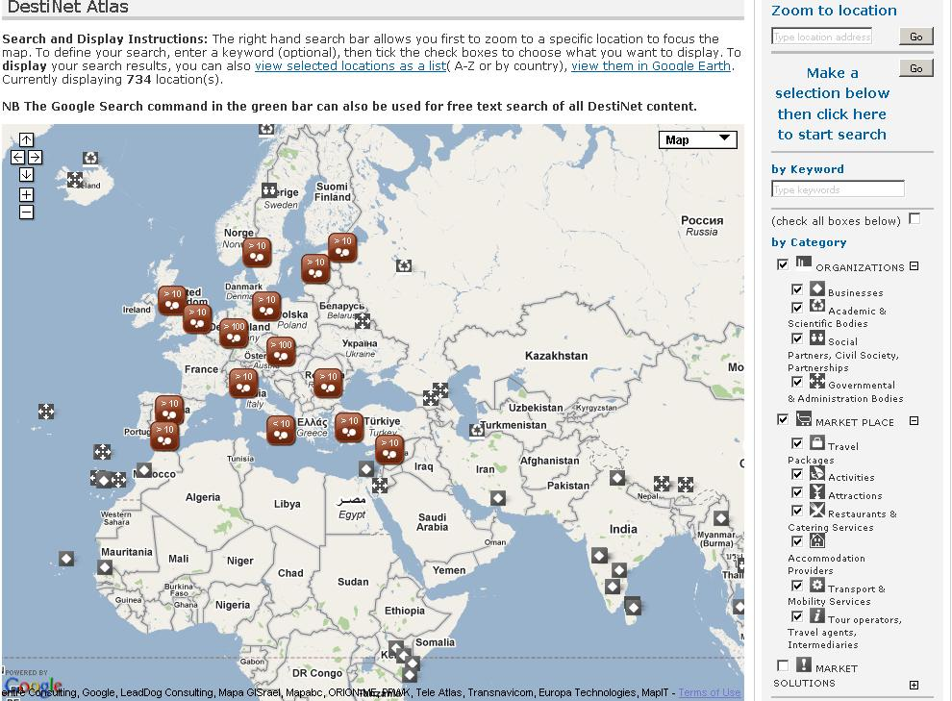Figure 11: The portal map on the DestiNet portal
The Geo Point page (index) also displays a small map with just that particular point and the nearby area. The zoom level of this small map is set by Administrators at the administration area.
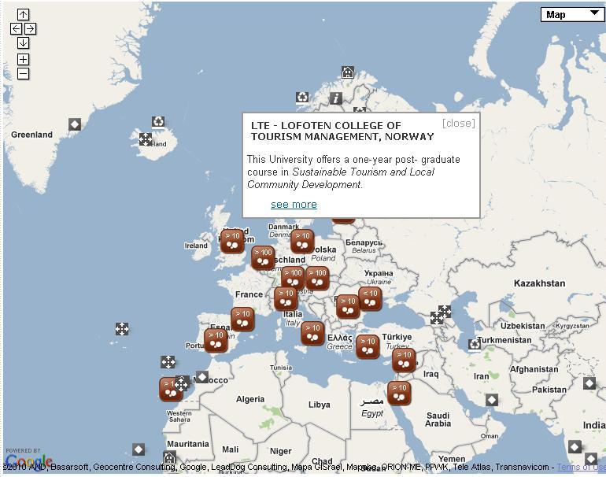Figure 12: Clicking on a Geo Point on the map
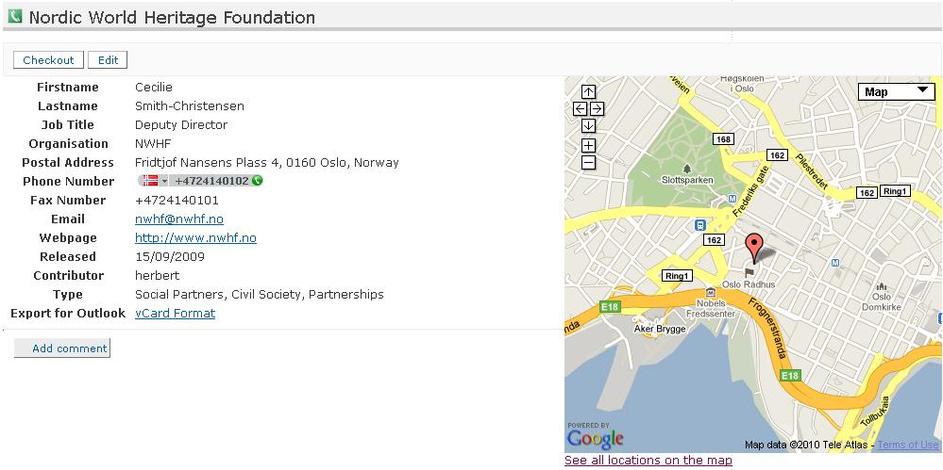Figure 13: Index of a Geo Point
A map is available on each Naaya portal at the address:

<portal_url>/portal_map

Additionally on the map page, an export of the selected points is available in Google Earth, provided that you have this application installed on your computer. This has the advantage that you can download these points as a layer and place them on top of other layers that you might have.
On browsers on which Javascript is not enabled, a tabular listing of the Geo Points is displayed, along with the button to export the in Google Earth. Therefore, these points remain accessible to people with various disabilities.

Publishing workflow
The (default) publishing workflow of the Naaya websites allows a contributor to submit the content (news item, HTML page, expert data, etc.) and an administrator (or, of course, manager) to review and approve/delete it. Before an administrator’s approval, that content is available in the portal but not visible to regular visitors. For obvious reasons, content posted directly by administrators is immediately published in the portal.
This way, the administrators can appoint a few persons to gather and post content and still have the final decision on what is actually published on their portal with minimum effort. If the ‘Maintainer email” property for the a folder is filled in with the administrator’s email, he/she receives a notification each time a piece of content is submitted in the portal. Multiple addresses can be specified here separated by commas.
Then, they access the corresponding “Basket of approvals” form which lists the pending content, allows its viewing and editing and gives administrators the possibility to approve (publish) or delete each content item by just clicking on the corresponding checkbox.
The full publishing workflow of Naaya portals and the actors involved in it are described by the picture below:
Figure 14: Complete publishing workflow in Naaya

Folder-level
All content is published in folders across the portals, so most of the content management facilities are available from each folder when logged on with a user that has proper rights (see section “Users and security” for more details).
The full set of possible operations is:
- edit folder properties including its metadata, maintainers emails, allowing user registrations, etc - “Edit Folder” button;
- define new objects available for that specific folder pushing the “Subobjects” button;
- publish pending items or revoke publishing status from the basket of approvals - “Approvals” button;
- setting the sort order of contained items (by default the items are sorted alphabetically by title) - “Sort order” button;
- restricting the folder from public view and granting access only to users with a certain role - “Restrict” button;
- CSV import, which allows importing objects from CSV files, following three easy steps: selecting object type, downloading the CSV template for that object type and filling out the rows, and finally uploading the CSV file; please note that the CSV file should be UTF-8 encoded;
- Zip import, which allows importing a ZIP file, in which case a folder will be created from the archive name and the contents of the archive will be represented as File and Folder objects in the newly created folder;
- cut/copy/paste objects from one folder to another (you need to make sure that you still have contribution rights in the target folder and that the target folder allows adding the copies/moved content types as sub-objects);
- renaming objects which means changing their ids, which implies changing the URL they can be accessed through;
- delete one or more contained items;
- submit items of the types which are listed in the “Type to add” selection box;
- edit or work on a version for each contained item;
- bulk download, which allows downloading selected files in a ZIP archive to a computer.
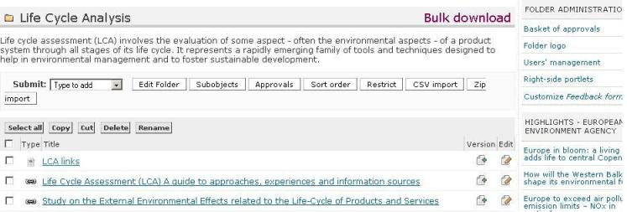Figure 15: Folder view for administrators

Local folder administration portlet
Aside from the content management operations, administrators can do more also at folder level:
- assign a logo which will be displayed on that folder and all its sub-folders;
- see the hierarchical basket of approvals (all pending content from that folder and its sub-folders);
- manage users at that level (grant/revoke local roles);
- display right-side portlets on that folder index;
- customise the feedback form at that level: when end users navigate through the content from that folder and click the “Feedback” link in order to contact the webmaster for questions and comments, they see a customised feedback form that goes to the local folder administrator and not at the site administrator.
All this functionality is also present in the administration area for the entire portal. The folder administration portlet offers quick links for administrators, but they are especially useful for local administration (users that have the Administrator role granted only for a folder, not for the entire site).
Therefore, it becomes easy for the webmaster of a Naaya portal to delegate authority for content management and site management onto trusted users, in the sections (folders) where their area of expertise is significant. The local administrators at their turn can do the same.

Default view and custom index
Naaya folders are shown to visitors as a listing of contained objects:
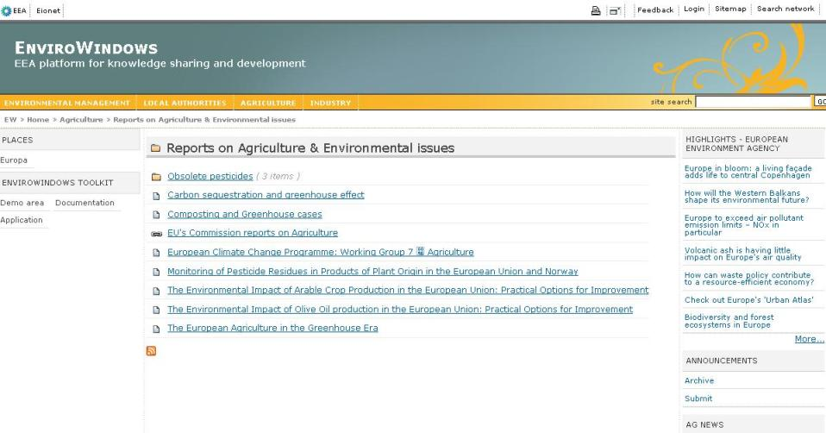Figure 16:: Default display of a Naaya folder
The sub-folders are listed first, then the rest of the objects. Authenticated users with content management rights see more toolbars and links to functionality that they can access.
If you want to add introductory text before the actual listing, edit the folder and fill in its description. Chances are that you sometimes need another display for a folder: e.g. a custom search interface, showing graphs and charts.
In these cases, a Manager can enter the ZMI for that folder, access the “Properties” tab and check the “Use/create public interface” option. Now, a Page Template called “index” will appear in the folder content just in the ZMI, not on the public interface.
It contains a copy of the folder index page written in TAL (Zope's Template Active Language). Managers that have the necessary programming knowledge can modify it to define custom views.
In this manual, the default display of a folder or another object will be also referred to as index.
Only indexes of folders can be customised for a particular item since the need for other types of content to have individually different displays did not come up amongst our users.
In any case, the forms that define how each object is seen by visitors are available to Managers from the ZMI -> portal_forms, under self-explanatory names, such as folder_index, file_index, news_index, etc. Managers can also find here the add and edit forms for all objects in case they want to change something inside. All forms are written in Zope's scripting languages for the interface TAL and METAL.

Working on versions (check-in/check-out)
Sometimes, there is need to work a longer time on a content item and save temporary versions each time you complete a part of it. However, you don't want site visitors to see intermediary unfinished versions of that text because it could be misleading or even incorrect.
There is a simple way to do that for Naaya objects – start a version of the document. When you navigate in a folder, you'll see a small image (a key with an arrow on top of it pointing right) next to each item that allows versioning.
This link is also provided when entering the object itself under the name “Checkout”. Upon clicking on this image/button, the item is reserved for your user to work on (having multiple users work on the same content in the same time leads to overwriting work). No one can now directly edit the item, just you can continue working on that version. Now the object looks like this:
Figure 17:: Inside a folder, "checkout" button for each item
and the editing on a version form looks exactly like the usual editing one, aside from two extra buttons that permit to “Commit” or “Discard” the changes.
Figure 18: Inside a folder, "version control" button for checked-out items
After multiple saving of changes (which are not visible to end users), the content manager commits (puts this version online) or discards (all the changes made since the version was opened are lost), allowing the item to be edited again.
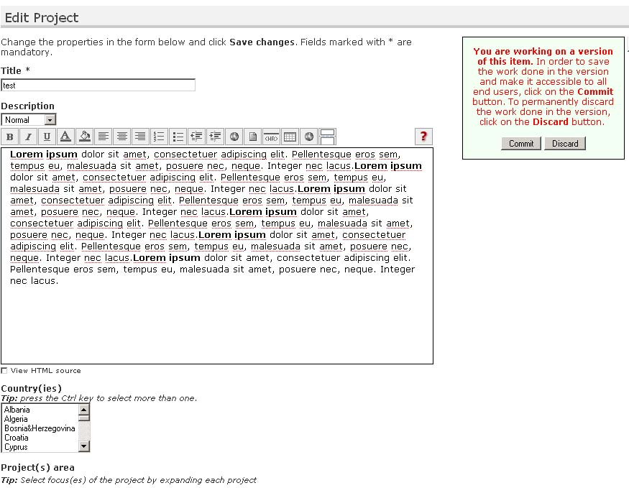Figure 19: Edit project on a version
As a safety measure, the administration form called “Version control” lists all items from the portal that have opened versions along with the user that opened them and allows administrators to discard changes that are not made by them (assuring that the content remains manageable after, for instance, someone resigns).

Comments to content
It is possible to open each piece of content for discussions by checking the “Open for comments” property when editing an item. Subsequently, a button saying “Login to add comments” or “Add comments” will appear to end users when they access that particular item of content.
By default, all visitors that have logged in the portal, regardless whether they have any roles or not, can post comments on items opened for discussions. The comments are shown in the order of their posting. When commenting, it is not possible to respond to a certain posting other that mentioning this in the text.
Administrators see a “Delete comment” button for each posting and, since the user name is displayed for each comment, they can take action (e.g. delete user) in case unwanted comments are posted.

Glossaries as picklists for metadata
The geographical coverage and keywords are part of the common metadata for all Naaya objects - they are actually Dublin Core (http://dublincore.org) elements. There is an important added value from properly indexing the portal content with terms taken from controlled vocabularies, glossaries or thesauri.
Mainly, it leads to better search results from external search engines and the possibility to build guided searches in the portal, where people would be able to pick the search terms from the same glossary or thesaurus used to index the data.
Therefore, administrators can decide to allow content contributors pick from glossary words when filling the geographical coverage and keywords fields for each item. It can be accomplished by accessing the Administrative area -> Portal properties -> Glossaries tab. In this form, choose a value from the “Keywords glossary” and/or “Geographical coverage glossary”.
You'll be given the possibility to choose among the glossaries available in your portal.
By default, no glossary is available in EnviroWindows portals, but Naaya has support for multilingual glossaries and thesauri as separate products and one can be easily created and filled in with data for you by Managers.

Allow user registration
Each folder can have a link in the bottom of the page that only appears to visitors that have not logged in (yet). It leads to a form of registration and asking for contribution rights in that part of the portal or on the entire portals.
The result is that an email goes to the administrator(s) with that request. The administrator can simply access the User management form and grant the appropriate role to the user, if needed. In any event, the user object is created upon submission of such request, even if no role is granted to it.
The fact that this link appears in the bottom of some folders is decided by the checking of the folder-level property “Allow users enrolment here?”.

Sub-objects
The list of object types you can add in a folder can be seen in the “Submit” selection box.
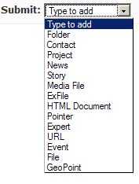Figure 20: Submit content in folders
There is a default set of Naaya objects that can be added in folders, established at portal level (ZMI -> portal_properties -> Subobjects tab).
So, when creating a new folder, content managers will be able to add those kinds of objects. It is also possible to change the sub-objects for each individual folders, also by accessing the ZMI for that folder (after the folder's URL type /manage) and from here clicking on the Subobjects tab.
When changing this list at portal level, only new folders created from that point on will have those setting, they would not be applied on existing folders – it would be rather difficult to make automatic decisions on folders that might have custom lists. If you want to take out or add some content type throughout the portal, a Manager would have to create a Python script that does that.

Portal administration
The portal administration area contains a set of forms for:
- setting various portal-level properties such as:
  - metadata – site title and subtitle, description (which appears on the front page of the portal), publisher, contributor, creator, rights
  - the two upper logos – for the left and right site of the top banner
  - email settings – containing the mail server used to send mails, the address from which the mails are sent, the list of emails of people that want to receive upload notifications and notifications on errors
  - keywords glossary – the glossary of terms used to index the content by filling in the keywords property of each item.
  - geographical coverage glossary – the possibility to pick a glossary containing the geographical regions and countries, used to fill in the “geographical coverage” property of each item.
No glossary is available by default for EW sites, but a Naaya Glossary can be installed and filled in by Managers, if necessary
  - various other properties relevant for the entire portal:
    - Show release date – this option allows leaving aside the release date from portlets containing the latest news or latest updates, which is useful when the content is rather old
    - Rename objects' ids – shows the possibility to change the ids of folders' sub-objects
    - Network registry – if you decide to make use of a network registry and declare the other members of your network, specify its URL address here. The Network Registry is used in searches across multiple websites and for storing the list of feeds (local channels) exposed by each participant portal
    - Portal URL – the URL your portal is mapped to. Even though your portal might respond to multiple URL addresses, this one should be the official one, used to send notification emails and for the information of system administrators. Before your portal is launched, this property should be empty
    - HTTP Proxy – if your portal is behind a proxy server, its address needs to be mentioned here. Ask your system administrators for details
    - RDF maximum number of items – the maximum number of items to include in the local feeds. If you don't put a limit for it (aka provide the value 0), channels such as “latest news” can contain a large number of items and therefore burden the server each time they are read by remote websites.
    - Allow switching language for content? - check this item if your portal has more than one language and you have wrongly published items in one language, when you meant to mark them in another. If checked, this option will appear in the edit forms for each item
    - Display contributor name in content indexes – when enabled, the index of all content types will show the name of the contributor who uploaded it.
    - Show how many objects are in a folder – when enabled, the folder index will show how many objects (sub-folders, sub-objects) are in each listed folder.
- layout customisation which allows choosing from the existing the existing layouts and colour schemes;
- users' management - allow managing users and their roles from one or multiple user repositories;
- translation centre for the messages across the portal, with the possibility to individually translate items or import/export all the translation in CSV, XLIFF and PO formats;
- managing the lists of links that appear:
  - in the header and footer of each page
  - in “list of links” portlets
- selection lists – which appear when adding/editing content types (e.g. when adding an event, there is a choice asking for the type of event; these choices can be set in the corresponding selection list)
- the listing of all portal contacts (content type that stores information about a person), allows import/export of contacts in vCard or CSV formats, and allows sending emails to all of portal contacts
- the possibility to send bulk mail to all users that have been granted a role in the portal (easily accessible in three steps – first, choosing the portal role you want to send a message to - for example, administrators; second step, selecting the person(s) from the portal role list exposed, and then, composing a message to be sent to the person(s) selected)
- Manage Notifications to which users have subscribed, be they instant, daily, weekly or monthly digest
- map management:
  - the “General settings” allow specifying:
    - Yahoo Maps API Key or Google Maps API Key – obtained freely from Yahoo or Google; there is also the possibility to set the map engine to Bing maps
    - Center location – the initial centre of the map, which can be a country or a locality
    - Center zoom – the initial level of zoom of the map, from 1 to 17, 1 being the most zoomed and 17 displaying the entire planet
    - Map height – the dimension in pixels you want your map to be appear on the screen
    - Detailed zoom – the level of zoom for the small map that appears on each Geo Point
    - Detailed map width and height – the dimensions in pixels for the small map that appears on each geo-tagged object
    - Choose possible and default map types – limit the background choices from the available list
    - The possibility to embed the map in another website
  - Location types allows managing the types of locations which can be added for geo-taggable objects and their icons; the icons will be used when locations are shown on the map
  - Bulk upload locations using a CSV template, in which case the system will create one Geo Point for each record inside the comma separated values file and automatically try to find their coordinates based on the addresses provided
  - Manage locations that lists all the geo-tagged objects found in the system, their coordinates and addresses, with the possibility to edit or delete them
  - Duplicate locations form that individuates possible duplicates based on the title, address or coordinates. It is then the Administrator's choice to remove some of them
  - Objects with no coordinates form which lists the locations that don't have coordinates.
- content management:
  - content type management, which allows configuring properties of all types of objects, as well as choosing which content types are geo-taggable.
  - overall basket of approvals, which lists the portal folders that contain pending items
  - version control that displays a list of all objects checked in for editing by various users
  - management of the main sections that are listed on the top bar of the layout, but can be also listed on the portal left side as a portlet
  - link checker which displays a log of the automatic or manual verification of all links (local or remote) found inside the portal content. For each possibly broken link, the log shows:
    - the item that link was contained by
    - the error encountered
    - the property of the object where the link appeared and
    - a link to the edit form of the item, so Administrators can correct the error if necessary
- syndication - allows defining and managing local and remote channels in Atom, RDF formats;
  - also makes possible setting up the “Portals in your network” list of remote website that can be used to set up a search across multiple portals.
Note: portals must implement and expose via XML-RPC similar functions to be possible to be added to the list
  - also lists the remote channels aggregators that can be defined by the portal administrator, which are collections of remote channels that contain all the data from the channels defined in the Remote channels section.
- portlets - define, edit or delete them and arrange existing portlets around the pages
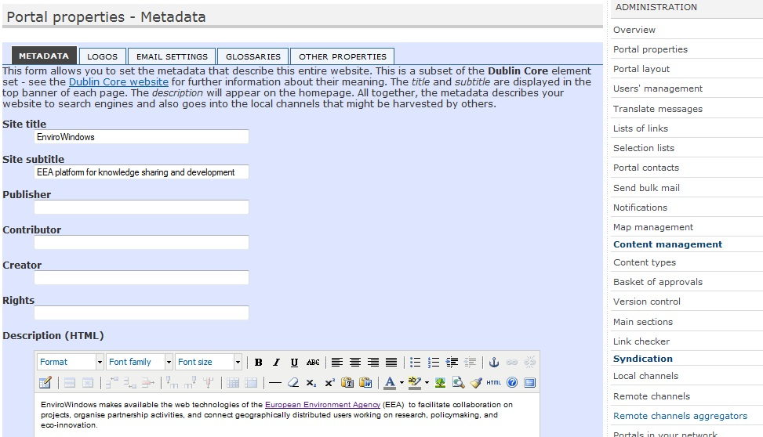Figure 21: Administration area, portal properties, metadata editing

Translate the website
Naaya portals are multilingual in terms of interface, content, search and syndication. Initially, the only available languages is English.
Managers can easily define additional languages in which the portal can be translated by using the Zope Management Interface. Add/remove languages operations can be done by accessing the Languages tab of the portal_properties object from the root of each Naaya portal;
Also from here, the default language of the portal can be set. Once a language is added or deleted, this is immediately reflected around the portal interface and content.
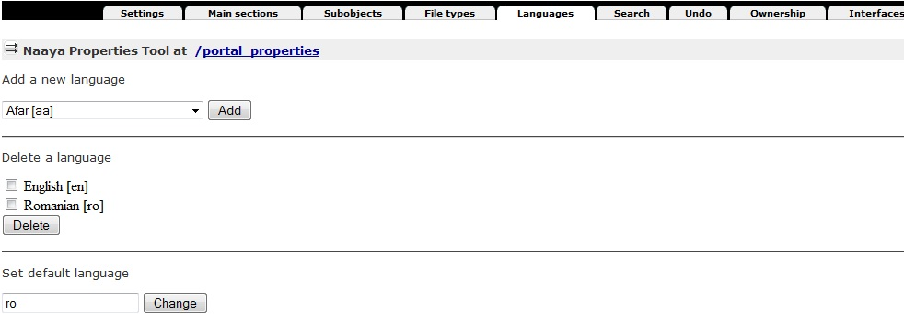Figure 22: Languages tab from portal_properties (ZMI)
All Naaya portal pages are encoded in UTF-8(Unicode) which means that all characters and signs from any language are supported.

The language negotiation process
Here's the full language negotiation process:
- Navigation language (end user selection)
- Preferred local language (client’s browser or operating system)
- Default portal language
When an end user opens a page from this portal for the first time, a localization process takes place and the Navigation language is set. If any match is found between the list of available languages for the portal and the languages in the browsers preferences, that language is set for the navigation language by default. If more language matches are found, then the first one in the settings of the browser takes precedence.
The end user can manually select the navigation language at any time and from any portal page from the list of available languages. This will overwrite all other settings done automatically by the system:
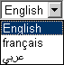Figure 23: Change languages selection box

Multilingual content
All types of content from the portal can be translated in each available language. An item can be added in just one language, which is the content contributor's choice (Posting language field on each submission form):

After that, the item can be edited in order to be translated. On the editing form of each item, the “Translate in” banner appears in the bottom of the page and it contains the available languages as buttons, as shown in the figure below:
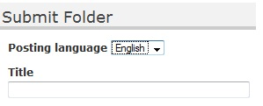Figure 24: Add form for folders
Here is what happens when a piece of content (a folder, a file, a news item, etc.) is not translated in a certain language:
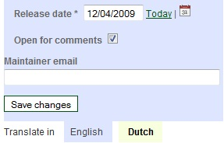Figure 25: Translate content toolbar
- first of all, the system searches for the translation in the portal default language (in this case English) and displays this one if available
- then, the system looks for a translation in the preferred local language (client’s browser or operating system) and displays this one if available
- finally, the system displays the item’s ID
This approach allows users to see that content exists in the portal and, even if they don’t understand the language that item is displayed in (because it hasn’t been translated in the chosen language) or just ID is shown, at least they know that additional data is available and, upon increased interest, they can ask someone to translate the content or they can write to the webmaster and ask for the translation.
Let's take the example of a portal being available in English and Romanian and the default language of the portal is English. If the local settings of my computer are Romanian (for instance the preferred browser language is Romanian or the entire system is installed in Romanian), the selected language will be automatically Romanian.
In this case, the content will be displayed as follows:
- if there is a translation in both English and Romanian of that item, I would be seeing the Romanian one
- if there is a translation just in English, but not also in Romanian, I would see the English version (because English is the default language)
- if only the Romanian translation is available (aka the item was added in Romanian and never translated in English), I would, of course, see the Romanian translations
What if my computer does not have Romanian as an alternative language? Here's what happens:
- if there is a translation in both English and Romanian of that item, I would see the English version
- if there is a translation just in English, but not also in Romanian, I would see the English version
- if only the Romanian translation is available I would see the id of the item and the text “Item only translated in Romanian” appearing next to it, with the possibility to click on Romanian and change the language correspondingly.
Below you can see screen shots of a news item published only in Romanian, in the two conditions described above:
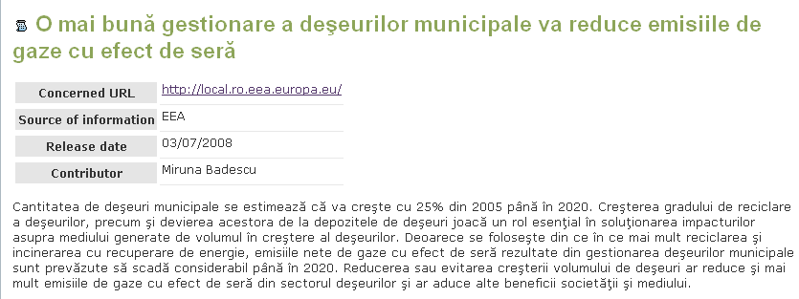Figure 26: News index when the selected language is Romanian
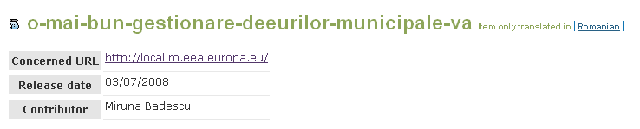Figure 27: News index when the selected language is English
Therefore, it is always a good practice to add items in the default portal language if you don't intend to translate them right away.
Note: not all the properties of content items need to be translated; some of them (e.g. dates, numbers, booleans, email addresses, some URLs) are not multilingual and will be filled automatically for each language on the editing forms.

Multilingual interface
All labels, explanatory messages, lists of links and their descriptions, the portlets (aside from the static ones) and other texts that appear on the user interface can be translated by specialised people into any of the available languages using the Translate messages form available in the administration centre. By default, only Administrators and Managers have the right to access this interface.
The translation centre for the interface lists the messages marked for translation in the portal and users can translate them individually. To ease the translation process, when a message is translated into a language, an OK sign will appear next to it in the language column. A message search is available, which will narrow down the list of messages to those that contain a certain text. Users can sort the list of messages, both ascending and descending: alphabetically or by translation status in a certain language.
                - 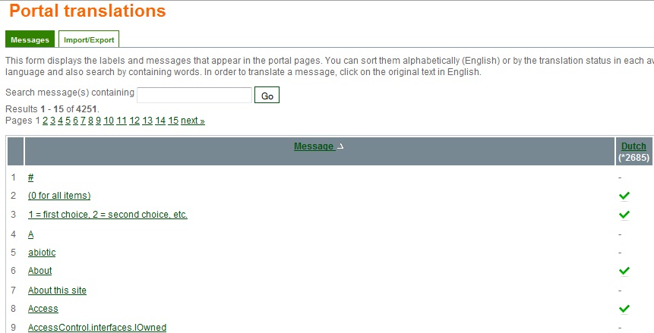– translation selection
                - 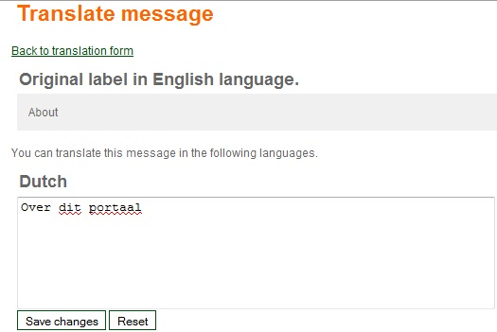– translation form
Figure 28: Translate messages from the administration area
Some of the messages contain HTML tags because splitting the texts around the tags would mean taking some phrases out of their context and therefore losing their meaning. All HTML tags MUST NOT be changed during the translation process.
When the portal has no translation for the navigation language, it will attempt to find one in the languages from the settings of the browser. Ultimately, the translation is shown in the default portal language.
Since the number of messages to translate is high, an export can be made in .PO, .XLIFF or .CSV formats, the texts translated using external tools (e.g. text editors, specific translation tools) and imported back into the portal. Such operation can be made from the Import/Export tab of the Translate messages centre.
The PO file is a simple text file which will be downloaded with texts in English and the target language in which the messages have to be translated, while the XLIFF file is XML and it's very good when the translators use desktop programs that know to navigate among the messages, to suggest translations, search messages, escape HTML tags, etc.

Multilingual searches
The free text search available in the portal is performed in any subset of the available languages on the portal. For each result, links to other available translations are provided.
Figure 29: Multilingual free text search for the SMAP portal

Multilingual syndication
All local channels of information generated in RDF format can be downloaded by end users in the language selected in the browser. Only items which are translated into that language are included in the channel. An item is considered translated into a language if at least its title is translated.
When administrators define the relevant channels exposed by their website, they are able to choose the language in which each one of them is generated. Alternatively, they can choose the “Auto” option, which returns all items, regardless of their translation status in one language, applying the generic language negotiation algorithm.

Change the layout
The user interface for the portal is based on templates for header and footer. The generic page structure is detailed in the image below:
Figure 30: Generic page elements
Modifying the user interface can be done from the administration centre as follows:
- Portal properties -> Metadata for editing the site title and subtitle, as well as the front page description;
- Portal properties -> Logos for the modification of the top-left and right logos. The default EnviroWindows design doesn't have logos on the top banner, but it is simple to display them using this form;
- Portal layout - for choosing the layout and colour scheme used. By default, EW portals come with just one layout and 17 colour schemes, but others can be created from the ZMI by specialised people (e.g. Web designers) and later selected from this page
- Portlets -> manage and arrange - allows adding, changing, deleting and arranging the portlets, which are boxes containing information. The portlets can be arranged in the left and right sides of the pages, and in the middle of the front page
Since the content is separated from the presentation and from the data, it is possible to create other layouts by accessing the ZMI -> portal_templates. In here, you'll find the EnviroWindows layout containing templates for the header, footer, left/center/right portlets and the colour schemes. Changing the template requires knowledge of TAL and METAL.
Creating or changing a colour scheme is however very simple for the web designers, since they need to make a copy of an existing one and edit the CSS files and/or replace the few images used in designing the template.
Here are some previews of available colour schemes for EW portals:
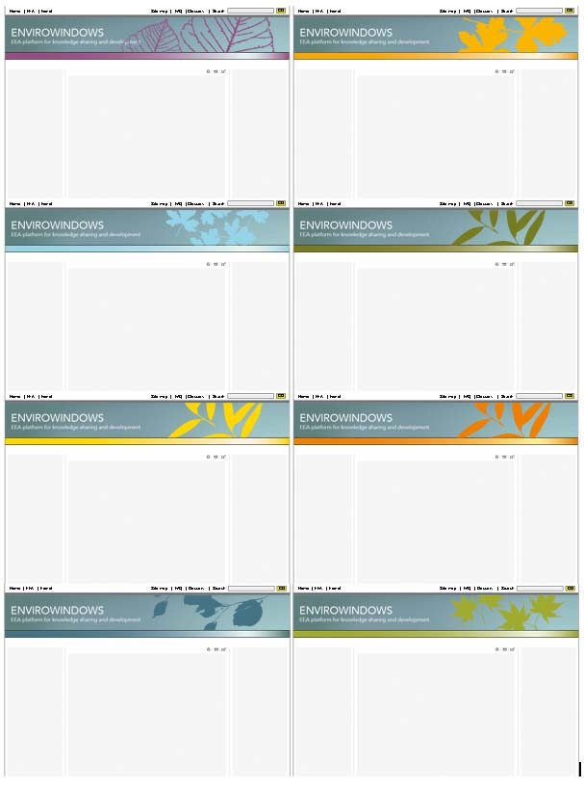Figure 31: EnviroWindows colour schemes
For each portal, new layouts can be created and the existing ones can be changed from the Zope Management interface by entering the portal_layout object from the corresponding EnviroWindows Site object. The easiest way to create a new layout is to copy the EnviroWindows one and to start modifying the ‘Naaya Template’s inside:
- portlet_center_macro – the template for the central portlets that appear on the front page
- portlet_left_macro – the template for the left-side portlets
- portlet_right_macro – the template for the right-side portlets
- site_footer – the dynamic page footer. Since Naaya Templates are XML documents, all opened tags must close and vice versa. That’s why this page also contains a dummy header area which only opens the tags that are closed in the actual footer. The two parts are separated by the string
<!--SITE_HEADERFOOTER_MARKER-->
- site_header – the dynamic page header. For the reason described below, this template also contains a dummy footer area which only closes the tags opened in the header; the tow areas are separated by the string
<!--SITE_HEADERFOOTER_MARKER-->
This offers a consistent look and feel throughout the entire site and gives visitors a sense of place and easy navigation.
Naaya websites are compliant with modern web standards such as:
- the website pages conform the Web Content Accessibility Guidelines 1.0 priority 2 (WAI-AA) for the end user interface
- the pages corresponding to the administrative areas of the portal are compliant to the Web Content Accessibility Guidelines 1.0 priority 1 (WAI-A)
- pages validate XHTML 1.1 Transitional
- the mark-up respects the semantic HTML rules
- the Cascading Style Sheets respect the CSS2 Specification
- the portal has a user-friendly interface built with respect of the most important usability principles
- the website is usable in any web browser
- the site information is accessible to all users (including users with disabilities), to all types of devices (different browsers, PDAs and mobile phones, TVs, speech synthesizers, Braille interpreters, TVs, printers, etc.) and to search engines.
The portal has different display versions for print (contains only useful content and ignores navigation elements). Try printing a page without making any choices or additional settings from that page or browser.

Portlets administration
The division of some parts of the layout into portlets is made available for its easy customisation by the Administrators, who can create and move around boxes of information that are relevant for that particular portal.
Portlet assignments are configured from the Portlets -> Arrange administration page. In order to create a new assignment, select its position, the portlet, whether it should be inherited, and then select its location (e.g. a folder). It is also possible to change the ordering of existing portlets by clicking and dragging the colored "position" field in the assigned portlets table. In this table, administrators can also choose not to have displayed certain portlets, by pressing on the “Remove”button.

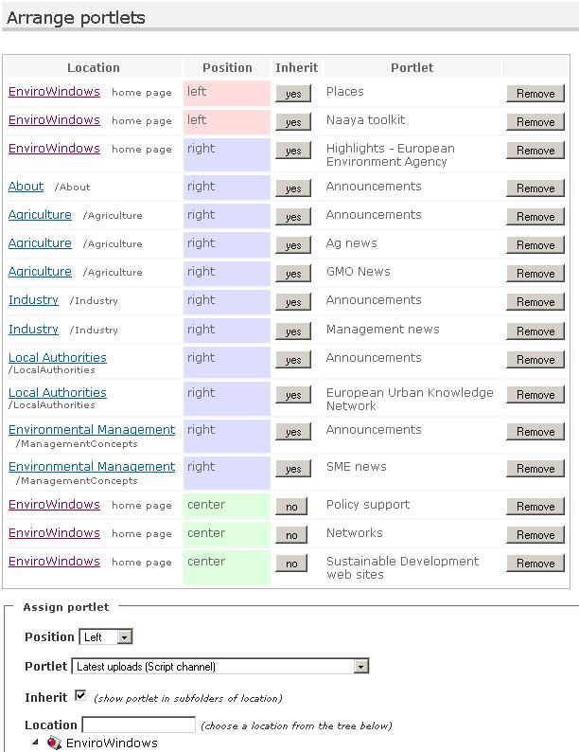Figure 32: Portlets: “Arrange portlets” form
In the “Arrange portlets” form, administrators can choose where to display portlets. Portlets can be shown on the left side, right side, or center (below the page content). Portlets can also be assigned to the entire portal or to a folder, and they can also be inherited (shown also in sub-folders) or non-inherited. For example, assigning a portlet on the site, non-inherited, will cause it to be shown just on the homepage, while assigning the portlet as inherited will display it on all pages in the site. There is a further restriction: right-side and center portlets are only shown on homepage and folder index pages.
The listing of the assigned portlets allows executing management operations as follows:
- changing the order the portlets are shown in a certain location by dragging and dropping the corresponding row up and down. For the drag and drop operation, the mouse has to be positioned on the “Position” column
- deciding to display each portlet
  - only in the specified location (home page or a folder) or
  - also in the subfolders of that location.
This is done by choosing “yes” or “no”on the inherit column of the table. For instance, if you want the left portlets to be shown on all the portal pages, you will choose them to be displayed on the front page and then set “Inherit” attribute to “yes”.
- removing portlets from the locations (which does not result in deletion of the portlet, just not displaying it in that location)

Note that portlets inherited from parent folders will always be displayed above portlets in sub-folders.

In the Portlets -> Manage administration page, it is possible to create several kinds of portlets. There are pre-defined templates for remote channel portlets (which display syndicated news/events from remote RSS feeds), local channel portlets (same for locally-generated feeds), folders (showing the contents of a folder), lists of links (showing links defined from the Administration -> Lists of links page). Administrators can also create portlets with static HTML content.
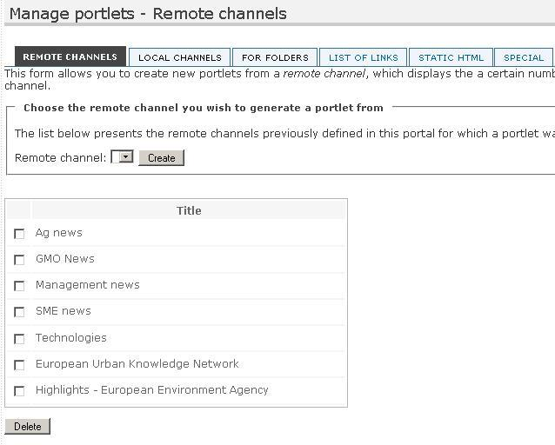Figure 33: Portlets: “Manage portlets” form, remote channels
1) Portlet from Remote channels
Such portlet will display the items of the selected remote channel (e.g. the news from another biodiversity website), showing their titles and the links to the corresponding page on the remote website.
Administrators can choose to create a portlet from a remote channel, if a portlet is not already defined for that channel. As a reminder, when users create a remote channel, they can choose to also create a portlet for it. If they don't at that stage, they can choose to create a portlet from here.
2) Portlet from Local channels
As in the case of remote channels, portlets created from a local channel display titles and links of the items included in that local channel. For instance, if you want to publish the latest news on front page, you will have to create a portlet from the local channel Latest news.
Similar to the remote channels, it is also possible to create portlets for local channels at the moment of their adding.
The maximum number of items that this portlet displays is set when creating the local channel.
3) Portlet for Folders
This kind of portlet is created as a quick link to the folder in the portal. The Administrators choose the folder from a small sitemap displayed in this page and the portlet generated will contain the title of the folder and its description, with a link to the folder itself.
Such portlet is useful when Administrators want to emphasise from the front page a folder where important documents are published.
4) Portlet from Lists of links
The lists of links can be created from the “Lists of links” administrative page and they are used to put together a collection of entry points – from the current website or external - useful to certain topic.
Like in the case of channels, this page offers the possibility to choose a list of links from the existing ones and creates a portlet with that list.
5) Portlet as Static HTML
This type of portlet has static text, images and links, that Administrators compose using the friendly HTML editor, the same editor used to add and edit the various content types. It is also possible to include films or other Flash or Javascript-based code taken from the local or remote websites by editing the HTML source of the portlet and pasting the corresponding HTML or Javascript code.
As opposed to the above-mentioned types of portlets, this one is multilingual and its title and body can be translated in all the languages available in the portal.
Additionally, the Manage portlets page lists a few portlets defined in the system that cannot be changed or deleted by Administrators. These portlets are called special and Naaya portals need them in order to work properly.
When Administrators need to create other types of portlets that require computation, for instance the items in the portal that are tagged with certain keywords or that have a certain geographical coverage, technical Managers can create these portlets from the ZMI, using TAL and Python.

Users and security
Three concepts govern the security mechanism in Zope and therefore in Naaya portals:
- Users - similar to the ones in operating systems. The user accounts have a case sensitive username and password; in Naaya, additional information is also attached for easier tracking (names and email address).
- Permissions - define granular rights that users might or might nor have. Permissions are not granted directly to individual users, but to roles.
- Roles - groups of users that receive the same set of permissions; after a role is defined, users are “granted” that roles either on the entire portal or just locally, on one or more folders. For instance, all users having the role of Contributor on the entire portal can submit content to the portal.
The security model of a Naaya-based portal is based on the concept that what you see is what you can do, meaning that whenever a user sees the link to an operation, he/she has the necessary rights to execute that operation. By default a set of roles are defined:
- content Contributors - only allowed to add content
- Administrators - can execute all operations available on the portal pages and administrative area, but not enter the ZMI
- technical Managers, with full rights to execute any set of operations
The list of roles can be tailored according with each specific portal needs, taking into account the wideness, skills and availability of the community that provides content and administrates the website.
Once users are defined in the system (have an account), they might be granted with any subset of the above roles (obviously having the Manager role eliminates the need for additional ones) on the entire portal or just on the locations (folders) they need to perform the operations that fall under their areas of expertise.
Naaya allows additional user repositories to be added if necessary. For instance, EnviroWindows users often have accounts in the Eionet LDAP directory, so this repository can be “plugged in” and used along with the local user repository (acl_users).
Only LDAP integration is shipped by default with Naaya, but others can be written by Web programmers as necessary.
When the LDAP repository is defined as an alternative source in a portal, a second tab appears in the Users' management area:
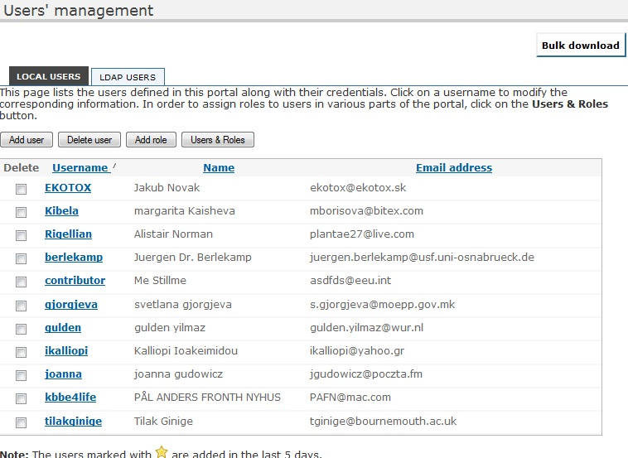Figure 34: Local user management form

While for the local users is possible to add, edit and delete accounts, LDAP users can only be searched in order to assign them roles. Local users can be assigned roles by clicking on the “Users & Roles” button.
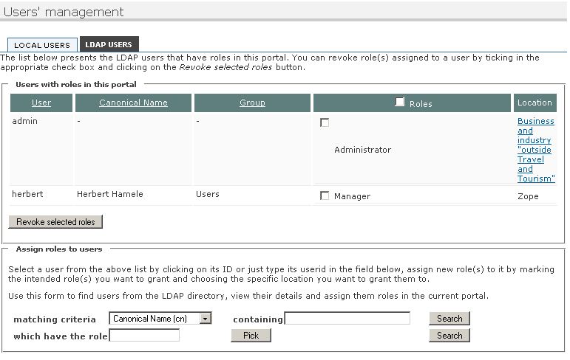Figure 35: LDAP user management form

Discussion forum
The forum is a place where users can exchange ideas and carry on discussions on various topics.
The administrators will open up different topics and invite communities to share opinions on each one. Depending on how sensitive the information is, it is possible to restrict some of the topics for particular groups.
When editing a forum, Administrators set the title, a short description of the forum, define the forum categories (ex: biodiversity), and can limit the size of the uploaded files. Also on forum level, Administrators define the permissions for the forum: add/edit forum topics, add/edit/delete forum messages.
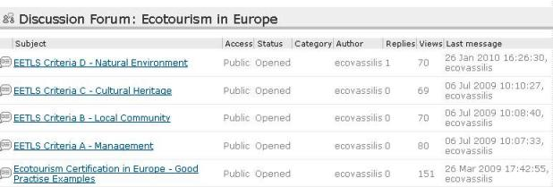Figure 36: Discussion forum on the DestiNet portal
Portal Administrators get to add, delete and edit topics. When adding a topic, the topic subject is defined, its category, and a file can also be attached, supporting the topic. Administrators also get to choose to be notified by mail of all postings on that topic. It's possible to close a topic, in which case people cannot comment anymore.
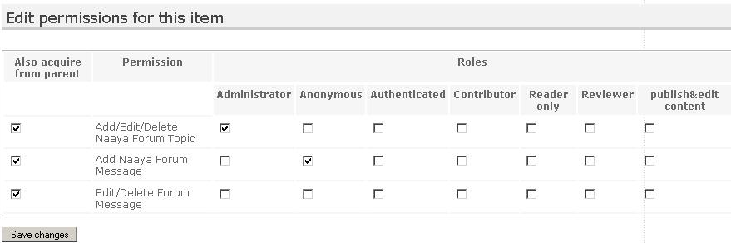Figure 37: Editing forum permissions
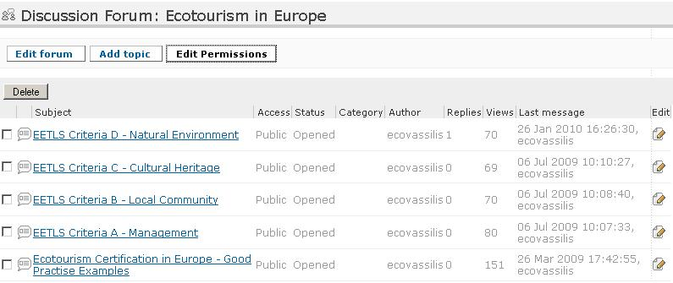Figure 38: Administrative functions of the forum
Inside a topic, the description and its attachments (optional) are the start of the discussion. Users that have the permission to answer that topic (by default Authenticated users) can post a reply to:
- the entire topic or
- someone else's answer
The administrators are able to delete certain answers and even to edit them, this way acting as topic moderator.
When new postings occur in a topic, notifications are sent to the owner of that topic.

The survey tool
This component lets content contributors create surveys that both authenticated and anonymous users can take. A survey is a research instrument consisting of a series of questions for the purpose of gathering information from respondents. The respondents are usually part of a community with relevant knowledge in the area of interest of your survey and they can be from a restricted group (authenticated users only) or part of the general public.
The answers to the survey can be analysed individually or they can be aggregated as statistics in reports. Both numerical and graphical statistics exist.
This is an optional component that may not come by default with your portal installation, but that can be added later. If you use it for the first time in a Naaya portal, enter the ZMI and add a Naaya Survey Tool in its root. This tool makes basic configurations in the portal, that allow surveys later defined to be indexed by searches, have a default notification mechanism and makes a default assignation of relevant permissions to roles (see the section about survey security).
A survey can be added inside Naaya folders, just like any other content type (e.g. Naaya Document, Naaya News). Go the folder where you want to create it and click on the Subobjects button. Make sure that Survey is selected in the list of object types, click "Save changes" and then go back to the folder index. This step needs to be done only once per folder if the survey type is not a default data type for the entire portal.
After submission, the administrators can change the survey's :
- metadata (e.g. title, description)
- attachments
- composing questions and
- its automatically generated reports
by using the upper toolbar buttons.
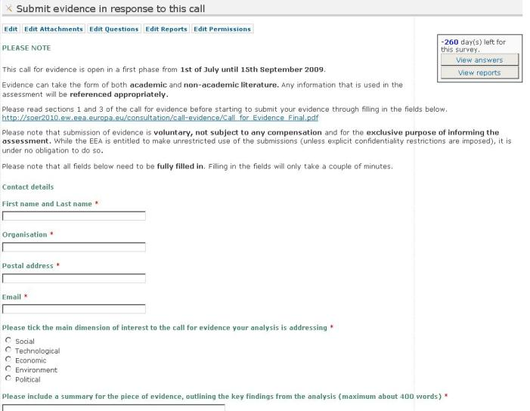Figure 39: the Survey index for Administrators
When editing a survey, you'll notice a few custom properties:

Users cannot take the survey before the release date. The expiration date disables the possibility to take the survey after that date if “Allow posting answers after the survey expiration date” is set to No. This proves useful since it is almost always the case for some (key) people not to be able to respond before the expiration date. In any case, the number of remaining days appears on the survey index and it urges people to respond faster.
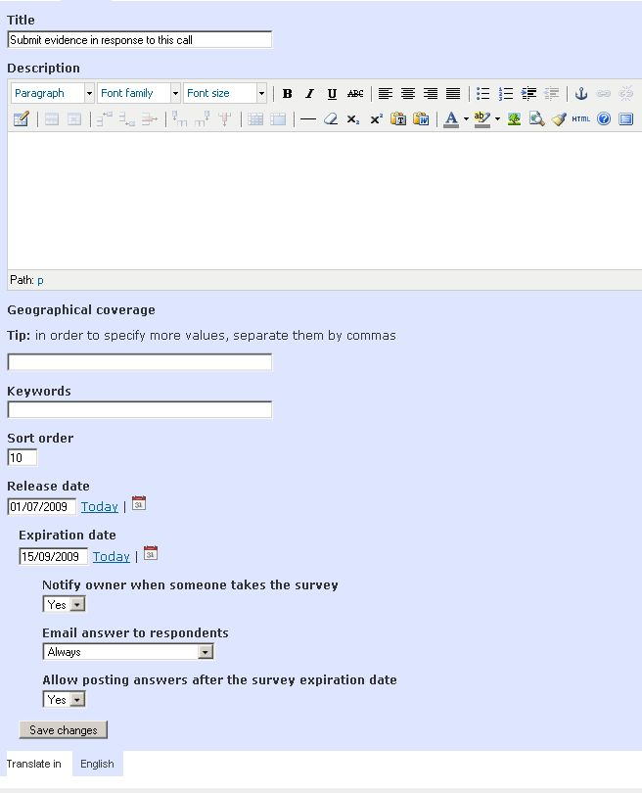Figure 40: The edit form of a survey

Attachments
When taking the survey implies having read some background documentation, the user managing the survey will upload these documents as attachments. When respondents take the survey, the attachments appear at the top of the page (below the description).

Questions
The following types of questions are supported:
- Multiple choice - one answer:
- Combobox
- Radio buttons
- Radio matrix (group of questions with one answer per row)
- Multiple choice - multiple answers:
- Checkboxes
- Checkbox matrix (group of questions with multiple answers per row)
- Single line text (free text input box)
- Paragraph text (multiple line answer, used for longer responses)
- Date (for date type answers)
- File (for letting the respondents back their answers with additional information inside files)
If you need to better describe certain sections of the survey, you can use the "Label" question, which has no answer. The respondent will only see the descriptive text.
After adding a question, you can further customize it (e.g. set the available choices) by clicking on the corresponding "Edit" button, or you preview it by clicking on its title.
To change the order of the questions, change the "sort order" column accordingly and press the "Set sort order" button.
 | 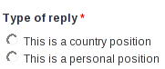
 | 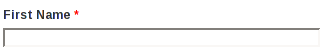
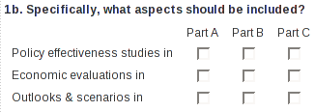 | 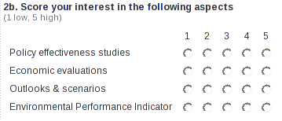
Figure 41: Some question type examples

Radio buttons questions
Sometimes the choices of a radio question might not be enough for the respondent. In this case you can let the respondent answer with their own choice. To do this, go the the edit page of the question and set “Add extra option” to “Yes”. The question will look like in the figure below.
If the respondent chooses the extra option, the choice will appear exactly as he/she entered it in the survey answer and as “Other” in the reports.
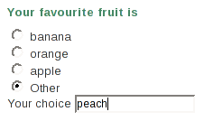Figure 42: Radio buttons question with extra choice | 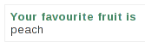Figure 43: Answer to a question with extra choice

Changing questions after the survey was taken
After the survey was taken, only a limited set of changes of the questions are permitted, e.g. the choices from multiple choice questions can't be changed. If no answer exists for a question , then the question can be changed in any way.
To delete the existing answers enter the ZMI and delete all the “answer_*” objects.

Reports
To analyse the answers of the survey by aggregating them, you might need to create one or more extra reports and add statistics to them.
Click on the "Edit Reports" button to go to the reports management section. To add a new report, choose a title for it and click on "Add report". To change its description click on the corresponding "Edit" button. To configure the statistics included in the report, click on its title. Now choose the question that will be included in the report and then what kind of statistics would you like. There are 2 major types of statistics: numerical (tabular) and graphical (charts).
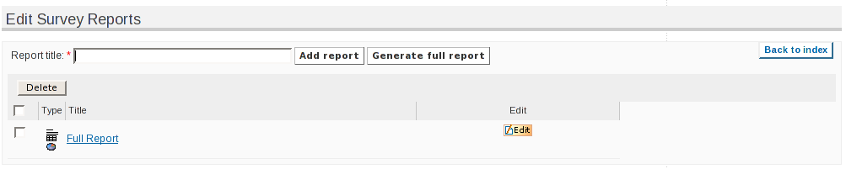Figure 44: Edit survey reports
Because adding a statistic one by one would take too much time for a complex survey with many questions, there is the possibility of creating a complete report with all the question - statistic combinations. To create this report, choose a title and click on the "Generate full report" button.

Email notifications
When a respondent answers, the owner of the survey can receive a notification email, which includes a link to the newly added answer. The notification can be enabled or disabled by using the "notify owner when someone takes the survey" setting.
After a survey is taken the authenticated respondents can receive an email notification with their answer by using the "Email me my answer" setting. In some cases, e.g. short surveys, it is desirable to let administrators disable notifications, while in other cases, e.g. large surveys, notifications should always be sent. This is why, the survey has an "email answer to respondents" setting (for administrators) with the following choices:
- Always - a notification is always sent to respondents
- Never - a notification is never sent to respondents
- Let respondents choose (default is yes) - respondents can choose if they wish to receive a notification; the "Email me my answers" setting will be checked
- Let respondents choose (default is no) - respondents can choose if they wish to receive a notification; the "Email me my answers" setting will be unchecked

Taking the survey
Send the link of the survey to the respondents, so that they can take it.
To prevent spam, a text recognition mechanism (CAPTCHA) is used for anonymous users. Authenticated users are permitted to answer only once, but they can change their answers any time they wish to.

Analysing the results
The user managing the survey can see the individual answers by clicking on the "View answers" button from the survey's page and selecting the answer he/she wants to see. Administrators have the possibility to download the list of answers in the CSV format.
While the individual answers can only be seen by a restricted group of users, the reports can be seen by anyone (if the default settings are used). To view the reports click on the "View reports" button from the survey's page and then select the report you want to see.
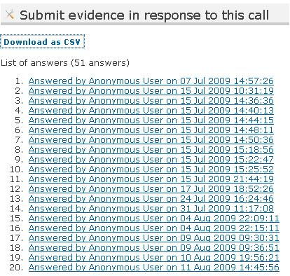Figure 45: List of answers
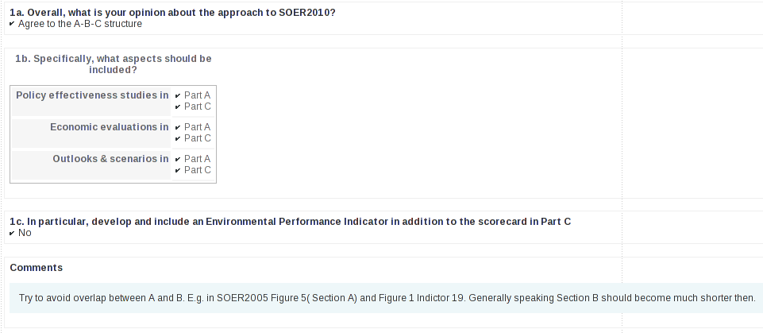Figure 46: Survey answer
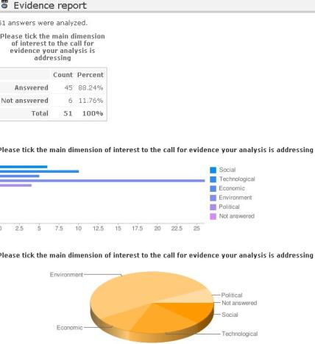Figure 47: Survey report

Consultation tools
These tools serve in getting feedback on a document from a user community. They allow uploading a file for each portal language, on which users can comment:
- freely, as overall comments
- for each line, in which case case the file must contain line numbers
- by answering guided questions previously defined by Administrators
- by adding files in support to their answers
- by inserting comments directly on the online text
When creating a consultation tool, Administrators should be aware of the capabilities of each tool before deciding which one to use.

Naaya Consultation
This tool is more complex and allows three types of users' review:
- responses to the questions prepared by Administrators (only if questions are defined for the Consultation)
- a file uploaded in support to the review (only of the Administrator checks the option)
- comments added for specific lines of certain pages (only if the Administrator checks the option)

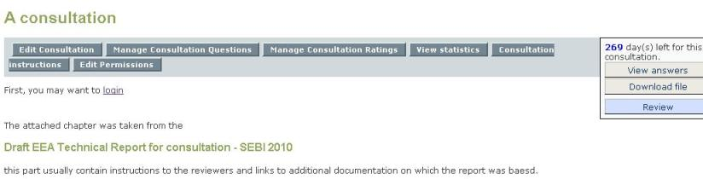Figure 48: Consultation front page - Administrator's view
When editing the Consultation item, Administrators can choose from the following:
- Allow visitors to register as reviewers for this consultation – option which adds a link to the registration page for unauthenticated users
- Allow reviewers to upload files when answering – option which enables the file attachment in the review
- Allow reviewers to post comments on lines in their answers – option which adds the possibility for responders to post comments for specific pages and lines
First of all, the Administrator needs to prepare the document for the consultation, following the instructions provided under “Consultation instructions”. Basically, it describes how to include line numbers into the file (useful only if commenting on lines is chosen) and how to include instructions in the file. Please note that this tool, along with the Simple Consultation entail that the users download the file, read it offline and than return to the website and post their comments. That is why the file has to contain clear instructions on how to return to the site and what is available for review.
After that, the Administrator uploads the file by editing the Consultation item and establishes a start and end date, in between which users can post comments.
The definition of the questions can be done by clicking on the “Manage Consultation Questions” button. Please note that questions cannot be deleted anymore after at least one review has been posted.

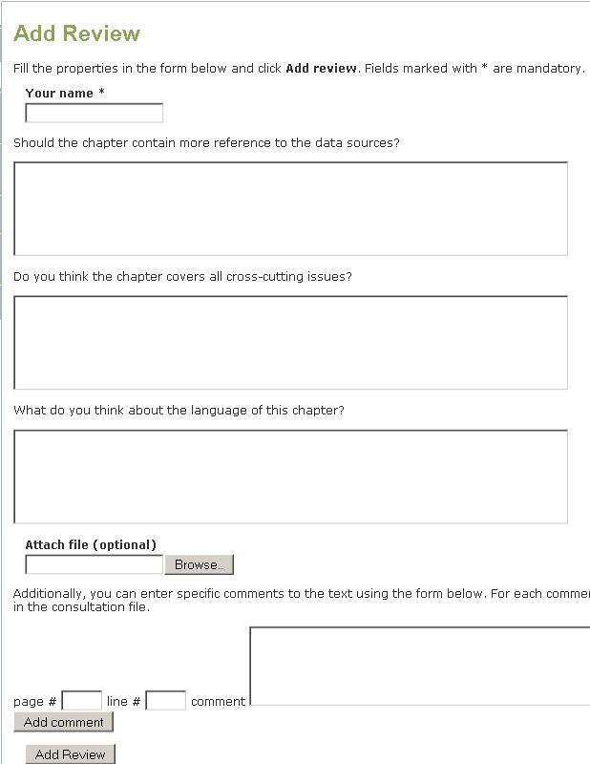Figure 49: Review page consultation - all options available
The list of all answers (reviews) is available by clicking on the right-side button “View answers”.
This page contains an extra-operation for the Administrators, namely providing ratings for each answer. The rating of each answer is not mandatory and it only appears if an Administrator has previously defined one or more rating categories using the “Manage Consultation Ratings” button. If a large number of reviews are expected and the result of the consultation needs to be made public, these ratings help sort the answers by filters such “Quality” or “Relevance”.
Aside from the simple listing of the answers, other statistics of the reviews are available for the Administrators: the number of people that have reviewed the consultation, the number of people that attached files or commented on lines and the listing of the answers on each question, along with their rating if they exist. Only Administrators have by default access to these statistics.
Notifications are sent to the Administrators each time reviews are added.

Naaya TalkBack Consultation
The TalkBack can be used to publish a series of articles and to let users comment directly on the text. Inside a TalkBack the idea is to define chapters like an online book, each chapter being divided by the system in paragraphs on which users can add comments.
As in the other cases described above, there is a start and end date between which users can comment.
When editing the TalkBack item, Administrators can choose from the following:
- Allow visitors to register as reviewers for this consultation – option which adds a link to the registration page for unauthenticated users
- Allow reviewers to upload files when posting a comment – option which enables the file attachment in each comment
- Allow reviewers to invite other people to review
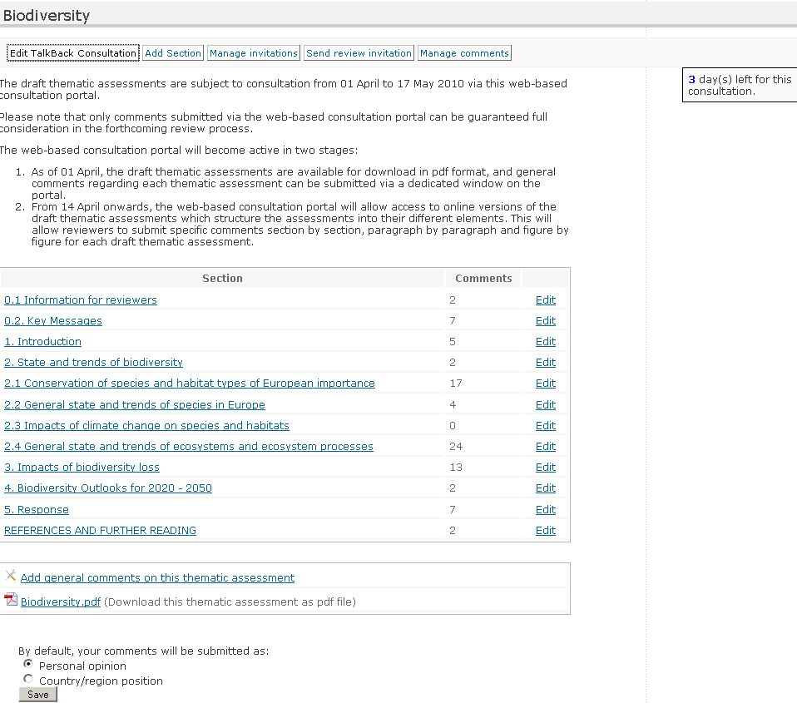Figure 50: TalkBack consultation - Administrator's view
By clicking on the “Add section” button, Administrators can define sections, one by one. The system will split the text into paragraphs, so the text must be either constructed using the HTML editor, or to be clean up first if it's pasted from another application (e.g. Word, PDF). It is possible to do this by using either the “Paste from Word” or “Paste as plain text” buttons of the HTML editor.
The reviewers will then see a button to comment on after each paragraph, as shown in the figure below:
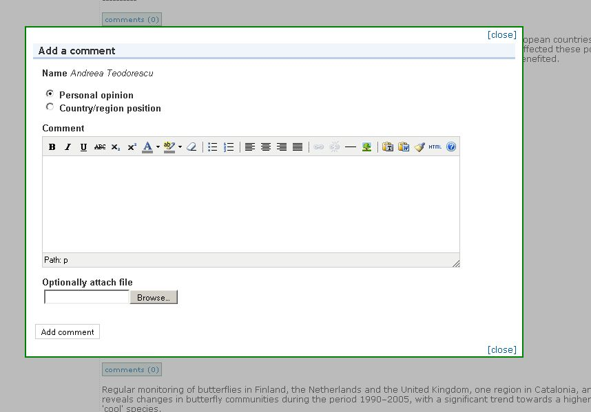Figure 51: Comment on the TalkBack paragraphs
The table of contents is available on the right side of each page and the navigation from one chapter to another can be easily made using the “Previous section” and “Next section”. If users will want to see the other comments previously posted on that chapter, they will click on the top button “Show comments”. Users can both contribute with comments to the consultation sections, and answer to already published comments.
When logged in as Administrator, it is possible to edit and delete comments, which makes it easy to moderate the feedback.
After adding a chapter, it can be edited by Administrators paragraph by paragraph, with the possibility to:
- Split a paragraph into two
- Merge a paragraph with the next one
- Edit the text from a paragraph
- changing the order of two paragraphs, by swapping with next paragraph.
Deleting a paragraph can be done by merging it with the next paragraph and editing the result to remove the unnecessary text.
Aside from the consultation editing, from adding/editing new sections to the consultation, administrators can also create and manage invitations, in the Consultation invitations form, respectively in the Manage invitations tab, from where they can invite people to participate in the consultation.
By using this invitation form, the invited persons will be notified by e-mail with a personalized link, and they will be able to submit directly their comments to the consultation, without the need to register and contribute directly in the portal. After they have contributed with their comments, such comments can be approved, edited or deleted by administrators.
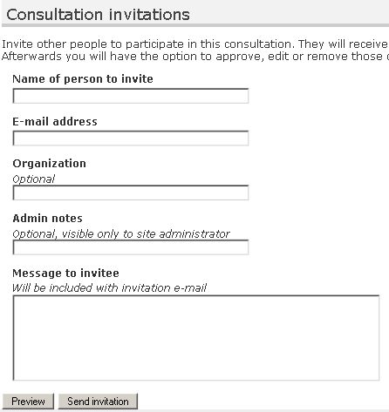Figure 52: TalkBack consultation – Consultation invitations form
These invitations can be managed from the Manage invitations tab, place from where active invitations can be revoked.
When going to the Manage comments tab, the total number of approved comments will be displayed by default, along with the number of unapproved comments and the number of comments submitted as an answer to the invitations sent by means of the Consultation invitations form.

Photo gallery
A photo gallery is a space for image publishing that can contain multiple albums, which contain photos, all described by metadata. Photos can be added either one by one or from a zip file. At album level, visitors can download either all the album photos, or a selection of the album, as a zip file.
One of the album's photos can be chosen as album cover. Aside from this, administrators can add and edit the properties of the galleries, albums and photos.
At photo gallery level, the options available are to define its title, define the key words and geographical coverage, restrict comments on the gallery, as well as restricting the access (when checked) to the original images; available operations are also defining the sort order, cut/copy/paste and deleting certain albums from the photo gallery.
When adding a new album to the photo gallery, administrators define its title, description, keywords and geographical coverage, can indicate specific attributes such as the author and source of the photos; they can also limit the maximum number of photos in an album, the maximum number of photos to be displayed per page, can restrict the access to the original images, can watermark the images with a pre-defined text, and geo-tag the album and its photos. As mentioned above, photos can be uploaded either one by one, or by uploading a zip archive in the album.
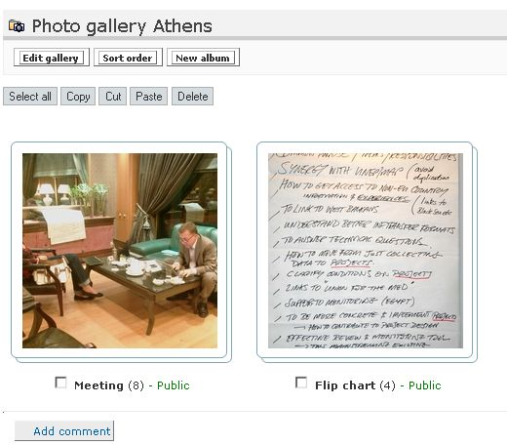Figure 53: Photo gallery - Administrator's view
Editing a photo album allows administrators to define the album's title, fill in a short description, define key words and geographical coverage; they can indicate specific attributes, such as the author and source of the photos, and can also limit the maximum number of photos in an album, as well as the maximum number of photos to be displayed on a page. Restriction to the original version of the photos can be also set here, and photos can be geo-tagged, as well as the whole album, by defining its geographic location on the map.

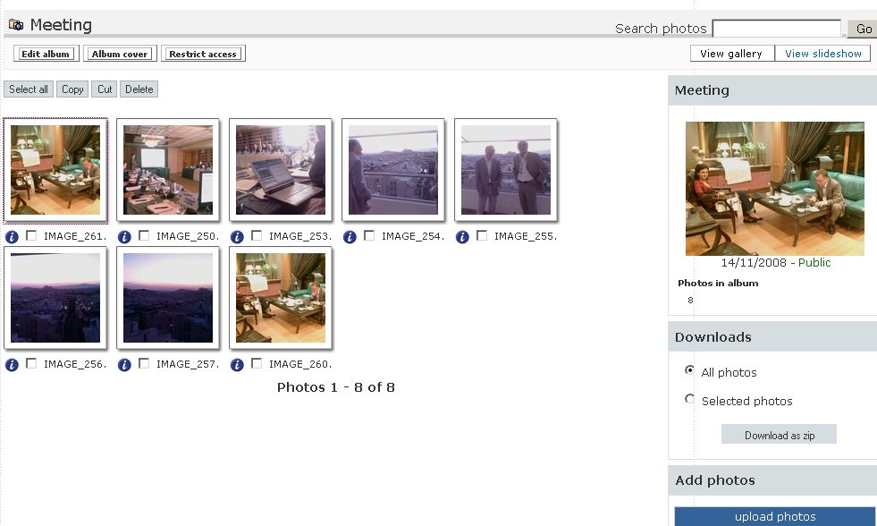Figure 54: Photo gallery album - Administrator's view
The index of an album displays the photos, some of the album's characteristics, the photo number, keywords, geographic location – map, and offers to users the download option, be it either selective, or bulk (entire photo album), as well as the possibility to add new photos to album. At album level, administrators have the cut/copy/paste option, as well as to delete certain photos of the album.
A photo search is available at album level for finding the search string inside the photos' metadata.
When adding a new album, its default status is public, accessible without restrictions to all visitors on the website. Administrators can opt for the Restrict access functionality,which allows restricting access or granting the access to that particular folder to a group of users, thus making the album no longer public.
When photos are uploaded, a few versions of each photo, with different dimensions, are generated: thumbnail, very small, small, medium, large and very large. Visitors see its thumbnail, but can also see, download and use the photo in any of these versions, along with the originals.
When clicking on a photo, visitors can go back and forth to the previous/next one, can see the whole photo album as a slideshow, can access the details and technical information of the photos and can visualize its geographic location.
In the same context, aside form the album navigation, administrators can also flip and rotate the photos using the buttons on top of the thumbnail if necessary, can replace certain photos in an album and geotag them.

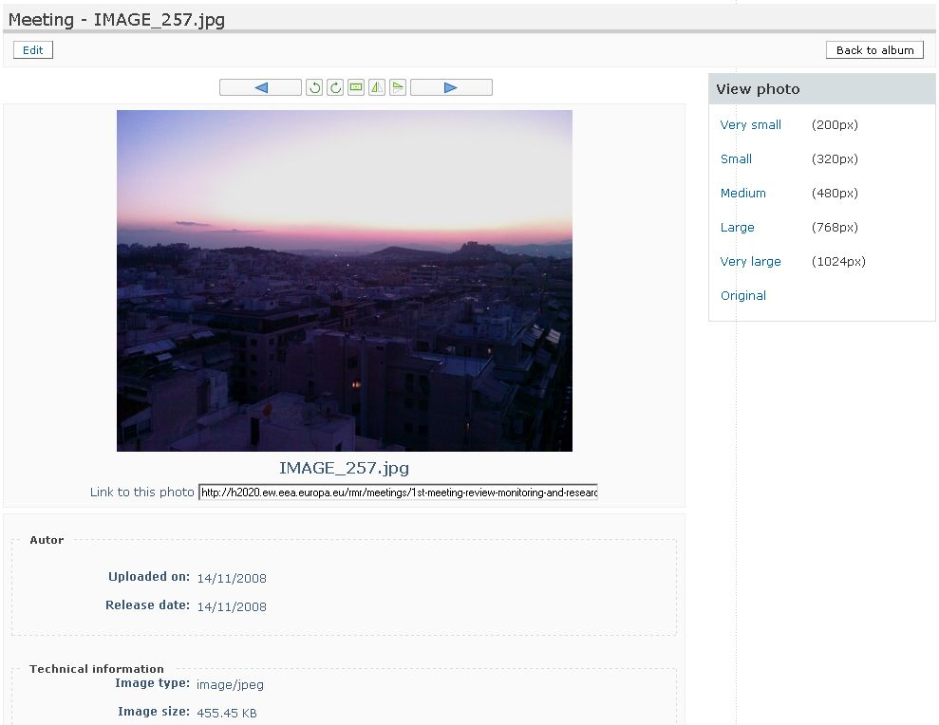Figure 55: Photo navigation - Administrator's view
The operations available for administrators are:
- add Photo Gallery/ Photo Album/ Photo
- bulk upload photos from a zip file
- edit Photo Gallery/ Photo Album/ Photo
- flip and rotate photos
- geotag photos/albums

Helpdesk agent
This tool allows tracking and responding to issues posted by a community of users. Users post their questions, comments or problem reports and resolvers carry out a discussion with them until the issues are concluded.

Administration
There are two roles in the Helpdesk Agent, independent from the ones in Naaya, due to the fact that this is a generic component which can work on any Zope website:
- Issue administrator – user who can manage all the aspects of the Helpdesk, as presented below
- Issue resolver – user who can see all public and private issues, respond and resolve them

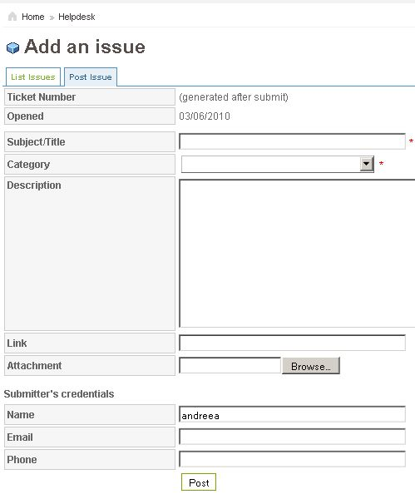Figure 56: Helpdesk agent - Post issue form
The entire administration of the Helpdesk Agent can be done only from the ZMI, by clicking on the Administration tab of the Helpdesk Agent object. It includes:
- Settings
  - User folder – the repository of users that will act as Issue administrator or Issue resolver
  - Mail server name and port – the mail relay used to send the notification mails
  - Notify users – allows choosing the events that will trigger notification emails; the choices are “adding issues” and “modifying issues”
  - From address – the email address that the notification emails come from, e.g. IssueTracker@mydomain.com
  - Subjects of all types of mails – allows setting the subject that will appear in each notification mail
  - Default Issue confidentiality – establishes whether a newly posted issue is visible to everybody or confidential; in any case, the resolvers can change the confidentiality status of the issue when responding
  - Priority set by – establishes if the users posting an issue can also set its priority, or if only the resolver can set it
- Priority: allows adding, deleting and changing the list of priorities issues can have and the order in which they appear; the default list is: low, medium, high, urgent
- Status: allows adding, deleting and changing the list of statuses issues can have and the order in which they appear; the default list is: opened, stand by, in progress, closed
- Category: allows adding, deleting and changing the list of issue categories, their default priority and their default assignee (i.e. user assigned automatically to that those categories of issues)
- Users: allows assigning one or both roles of Issue administrator and Issue resolver to users from the chosen user repository
- Presentation: allows choosing the format in which the dates are displayed, whether or not to show the time next to the date, and the number of issues which will be listed on the “List issues” tab of the Helpdesk
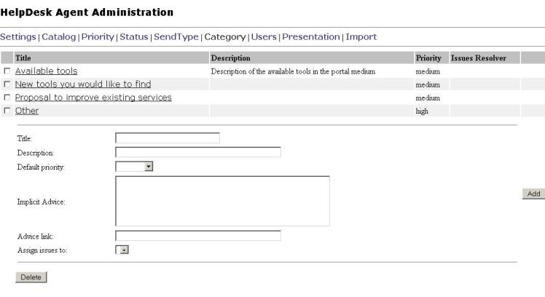Figure 57: Helpdesk administration in ZMI - Category form

Usage
The Helpdesk Agent user interface contains a starting page with explanatory texts and three tabs:
- List issues, that provides a sortable table with all issues and a search form; when logged in as Issue resolver or administrator, both private and public issues are displayed
- Post issue, which allows posting the issue description
- Reports, available to Issue resolvers and administrators; this page offers statistics about the number of issues posted for each category, with each priority, with each status, and also which are assigned to each Issue resolver
When end users fills in the“Post issue” form, an email notification is sent to the person who posted the issue, as well as to Issue Administrators and Issue resolver, if one is already assigned.
If the issue is not automatically assigned to an Issue resolver, the Issue Administrator assigns one for the list. The resolver is the person with the necessary expertise to solve the issue, so he or she marks the issue as being in progress and starts posting comments on it, in response to the initial question. The owner of the issue replies also by posting comments, and there can be a longer discussion with the resolver through these comments, that leads to the closer of the issue. When solved, the issue should be marked as closed.
Each time an issue is changed, notification emails are sent to all people involved – person that posted the issue (if the correct email address was provided), Issue resolver and Issue administrators.

References
Web Content Accessibility Guidelines (WAI )
http://www.w3.org/TR/WAI-WEBCONTENT/
XHTML 1.0
http://www.w3.org/TR/xhtml1/
Zope documentation
http://www.zope.org/Documentation/

Because either the question did not exist at the time the survey was taken or the respondent did not answer.

